**ArtVision: Collaborative E-Commerce Art Gallery Platform:**

**Project Idea:**

Our goal is to build a fully integrated art gallery website that allows users to create accounts, share artwork, and make purchases. The website will provide a platform for artists and art enthusiasts to connect, explore, and transact with ease and security. It's a project inspired by popular art platforms such as DeviantArt, Behance, Dribbble, and ArtStation.

**Team Members:**

Jesus Zubia, Obie Carnathan, Katrina Murrell, and Daniela Chavez

**Technologies Planned for Use:**

**Front-End Development:**

o HTML/CSS: To create the structure and design of the website.

o JavaScript: To add interactivity and dynamic features.

o React: To simplify the development process and enhance user experience.

**Back-End Development:**

o Python/Django: Our chosen server-side programming language and framework.

o PostgreSQL: Our chosen database to store user information and artwork details.

**User Authentication and Account Management:**

o Firebase Authentication: To handle user registration, login, and account management.

o User Profile Features: To allow users to create and manage their profiles and update personal information.

**Artwork Display and Gallery Functionality:**

o Art Upload: All users, regardless of account status, will have the ability to upload artwork to the platform. This not only simplifies the uploading process but also provides a more inclusive environment for creativity. Additionally, each user will have a personal gallery on their profile, where their uploaded artwork will be showcased.

o CSS Grids/Masonry.js: To create a responsive and organized gallery layout.

o Art Discovery: Implement basic tags or categories for easy discovery and filtering of artwork.

**Art 'Purchase' Functionality:**

o Purchase’s Functionality: Users will have the option to make their artwork available for purchase. By clicking a 'purchase' button, the system will deduct from the artwork's quantity. The original uploader will be notified of this action, ensuring they remain updated about their listings. No actual payment processing will be implemented for this project.

o Seller Interface: To complement the Purchase Functionality, a user-friendly interface will be created for sellers. This interface will allow them to view, edit, and delete their art listings as per their requirements, providing them with full control over their content and sales.

**Security and Performance:**

o SSL Certificate: To enable secure connections (HTTPS) and protect user data during transmission.

o Performance Optimization Techniques: Such as caching and code minification to improve website performance and load times.

-------------------------------------------------------------------------------------------------------------------------------

**Meeting Notes: ArtVision - Collaborative E-Commerce Art Gallery Platform**

**Date:** July 13, 2023

**Participants:** Jesus Zubia, Obie Carnathan, Katrina Murrell, and Daniela Chavez

**Agenda:**

1. Website Structure
2. Technology Stack
3. Work Division
4. Meeting Schedule
5. Goals and Deadlines

**Notes:**

**1. Website Structure**

Our proposed website will be comprised of six key pages:

*Information Pages*

**Main Page:** Features art pieces available for purchase, organized into rolls/cells. Users can click on an art piece to view and/or buy.

**User Profile Page:** Hosts relevant user information, including art pieces bought, sold, and uploaded.

A user’s profile from the eyes of another user should show the user’s bio/photo and all art uploaded by that user. The art will either be sellable or just simply available for viewing.

**Art Information Page:** Displays specific details about the selected art piece (i.e., upload date, creator, title, description) and provides the option to buy.

*Functionality Pages*

**Art Purchase Procedure Page:** Outlines the procedure for purchasing an art piece.

**Art Selling Procedure Page:** Details the steps required for selling art pieces.

**Art Upload Procedure Page:** Guides users on how to upload art pieces.

**2. Technology Stack**

After deliberation, we have proposed the following stack for our project:

**Front-end**: JavaScript, HTML/CSS

**Back-end:** Python

**Database:** PostgreSQL

*Note: We will double-check the acceptability of these technologies before our next meeting.*

**3. Work Division**

Team roles have been allocated as follows:

**Front-end Development:** Obie Carnathan, Daniela Chavez

**Web Design:** Daniela Chavez, Katrina Murrell

**Back-end Development:** Jesus Zubia, Katrina Murrell

**Database Management:** Jesus Zubia, Katrina Murrell

*Note: All roles are flexible and may be adjusted as needed.*

**4. Meeting Schedule**

Team meetings will be held twice a week at 7:30 CT/8:30 ET every Monday and Thursday.

**5. Goals and Deadlines**

For the first week, we aim to complete a basic version of the six key pages. The design and full functionality will be refined in subsequent weeks. Please note that this does not mean they need to be interconnected or have working functionalities at this point, but should exist in their basic format.

Our timeline is as follows:

* **Week 1:** Basic structure for all six pages
* **Week 2:** Design and functionality improvement (TBD)
* **Week 3:** Finalization and Testing (TBD)

**Next Steps:**

1. Each team member begins work on their assigned tasks.
2. Validate the technology stack.
3. Prepare for the first weekly goal of creating the basic page structure.

**ArtVision:  
A Virtual Art Gallery & Social Platform**

developed by

Obie Carnathan  
Daniela Chavez  
Katrina Murrell  
Jesus Zubia

CS 421/621 Advanced Web Development  
August 4, 2023

1. **Introduction**

*“See the world in new colors.”*

The purpose of this project was to develop ArtVision, a virtual art gallery and social platform for artists—hobbyists and professionals alike—to share their work, sell prints, and above all else immerse themselves in a community of fellow art enthusiasts. This report encapsulates the processes, technologies, and crucial functionalities that contributed to the realization of ArtVision.

1. **Project Planning and Communication**

Active participation and consistent communication were key to the success of ArtVision’s development. Each team member attended all meetings and was involved in decision-making processes every step of the way. GroupMe and Discord served as our main channels of communication, fostering swift idea exchanges and problem resolution.

* 1. **Meeting Highlights:**
* **Meeting 1: Week of July 10, 2023**
  + Determined the structure of the website comprising six key pages.
  + Choose the technology stack, including Django as the web framework and SQLAlchemy/Flask_SQLAlchemy for the database.
  + Allocated team roles for frontend and backend development, web design, and database management.
  + Set a meeting schedule along with project goals and deadlines.
* **Meeting 2: Week of July 17, 2023**
  + Created a basic structure of the web pages using HTML and CSS, without incorporating any functionalities.
  + Finalized the decision to transition from SQL database technology to SQLAlchemy/Flask_SQLAlchemy for the application's database structure, and initiated work on it.
  + Created a draft of the website's design using Figma, including finalized logos. Discussed the implementation of functionalities.
* **Meeting 3: Week of July 24, 2023**
  + Began the implementation of CSS/HTML designs, importing the necessary modules for functionalities.
  + Initiated the implementation of functionalities for various operations, such as uploading, selling, and buying artworks, along with the user login/logout mechanism. Included a view option for art pieces.
  + Integrated Amazon Web Services (AWS) for hosting our application and managing resources. Utilized key services such as Amazon S3 for storage, and this step ensured the scalability and robustness of our platform.
* **Meeting 4: Week of July 31, 2023**
  + Commenced work on the project report.
  + Fixed the logout issue and updated the navigation bar functionality.
  + Scheduled a meeting with Unan to discuss project requirements.
  + Outlined future tasks including development of user profile page, checkout functionality, and design enhancements.
  + Decided to finalize the application with comprehensive error testing.
  + Planned to work on a presentation video that includes a short demo of our application.

1. **Website Features**

*\*Features that were not implemented by the project deadline or are unstable are highlighted.*

* **Landing Page**
  + Options to create an account, log in, or continue to the explore page without an account
  + Features a slideshow background of randomly selected artwork, as well as details about the artwork in the lower right-hand corner of page
* **Explore Page**
  + Search
  + Options to view artwork by popularity, recent upload date, and category
  + Link to a random artwork
* **User Profiles**
  + Show info about the user (display name, pronouns, title, bio, date joined)
  + Gallery tab - art user has submitted
  + Shop tab - prints the user has made available for purchase
  + Favorites tab - art user has added to their favorites
  + If user is logged in, shows options to edit account and manage gallery (delete artwork)
* **Edit Account** 
  + Update user profile information
    - Change username, display name, pronouns, title, or bio
  + Update account information
    - Change email or password
    - Requires users to verify their current email and password
  + Manage account
    - Option to delete account
* **Artwork Detail Page**
  + Show info about the artwork (artist name, description, category, upload date)
  + If a print of the artwork is available for purchase, display price details and purchase option
  + If user is logged in, shows option to add the artwork to their favorites
  + Comment section
    - Users must be registered and logged in to leave a comment
* **Submit Artwork**
  + File upload
  + Provide artwork information (title, description, category)
  + View a thumbnail of file upload
  + Users must be registered and logged in to submit art
* **Sell Prints**
  + File upload
  + Provide artwork information (title, description, category, price)
  + View a thumbnail of file upload
  + Users must be registered and logged in to sell art
* **Purchase Prints**
  + View selected artwork labeled to be sell within the shop page
  + Within each artwork will redirect to the artwork information page
  + Provide artwork information (author, date of publication, description, title, price)
  + Users must be registered and logged in to purchase prints
  + After artwork has been added to cart, users will be able to finalize purchase through the shopping icon demonstrating their total amount
* **Administrative Role**
  + There are no admin users at this time but we do have a page to access important site data.
  + User Management
    - View all ArtVision users and their account information
  + Artwork Management
    - View all artwork submitted to the site
  + View all transaction information

1. **Website Mockup**

To view designs for each of ArtVision’s (initially planned) pages, visit the Figma board: <https://www.figma.com/file/jYv5IE4s6qmNwuADLbjczi/ArtVision?type=design&node-id=0-1&mode=design>

1. **Selected Pages:**

**Landing Page  
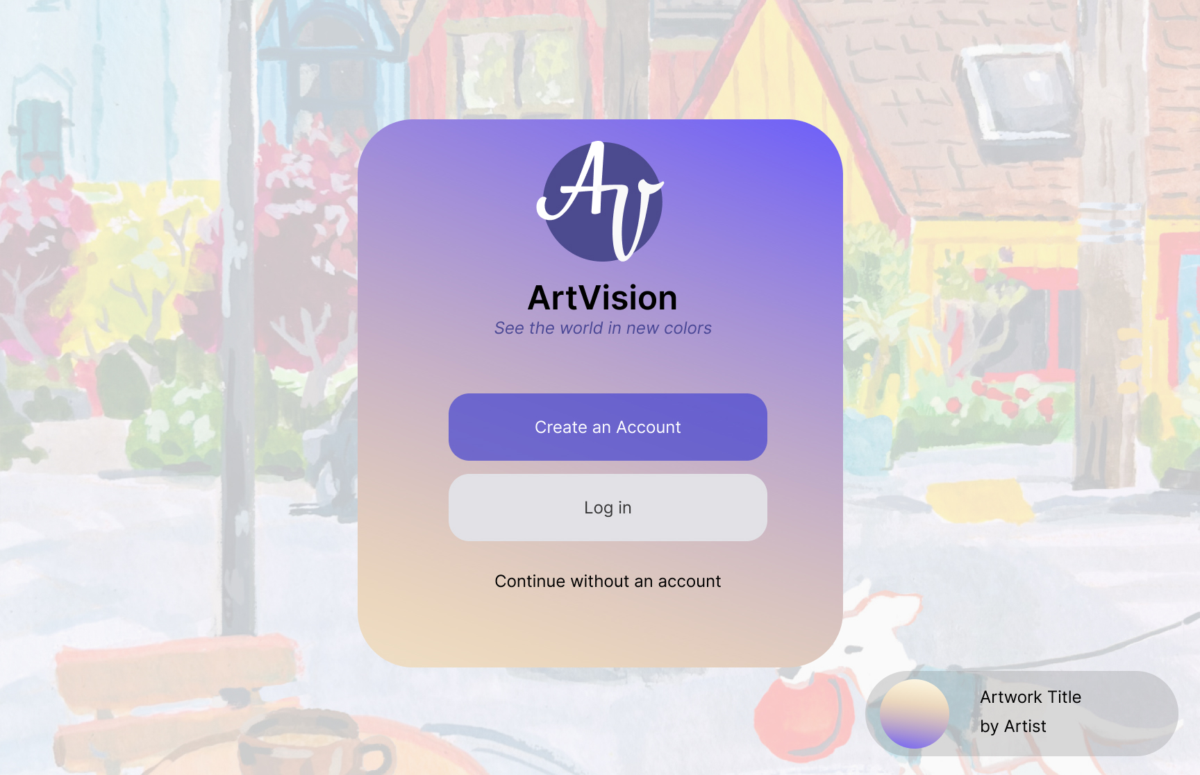  
  
Explore Page  
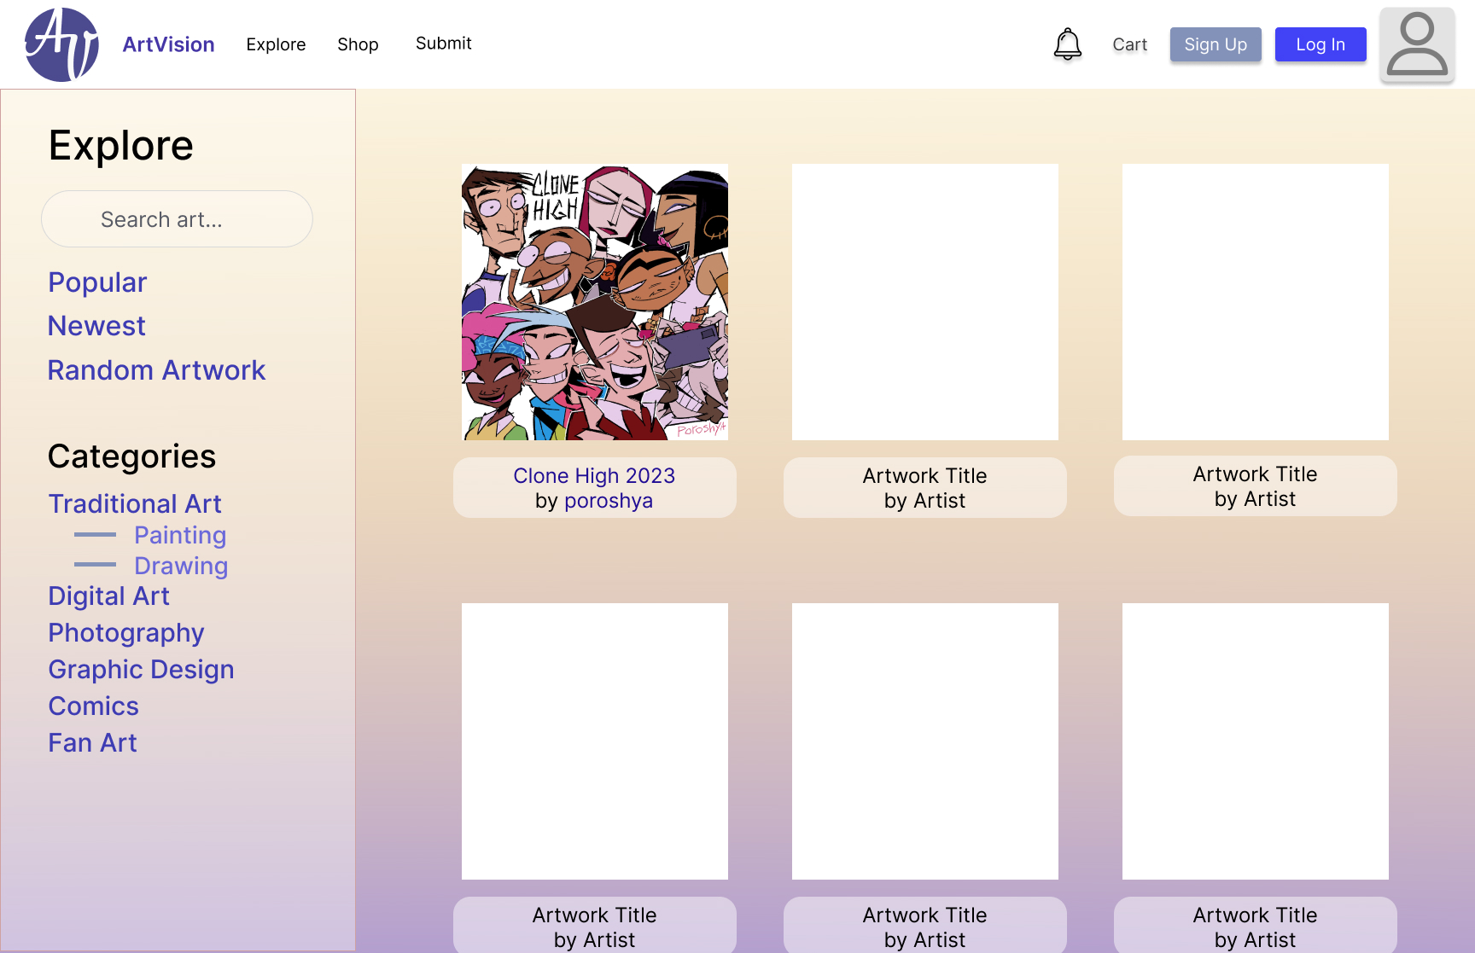  
  
  
  
Artwork Detail Page  
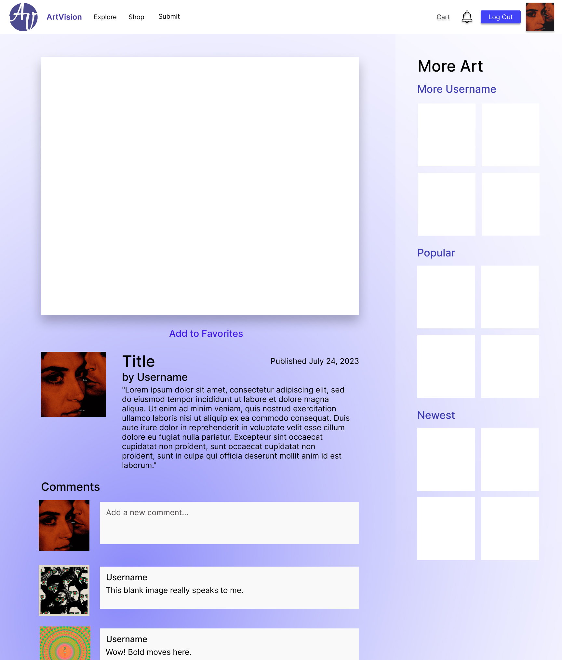  
  
  
  
User Profile Page - Shop Tab  
  
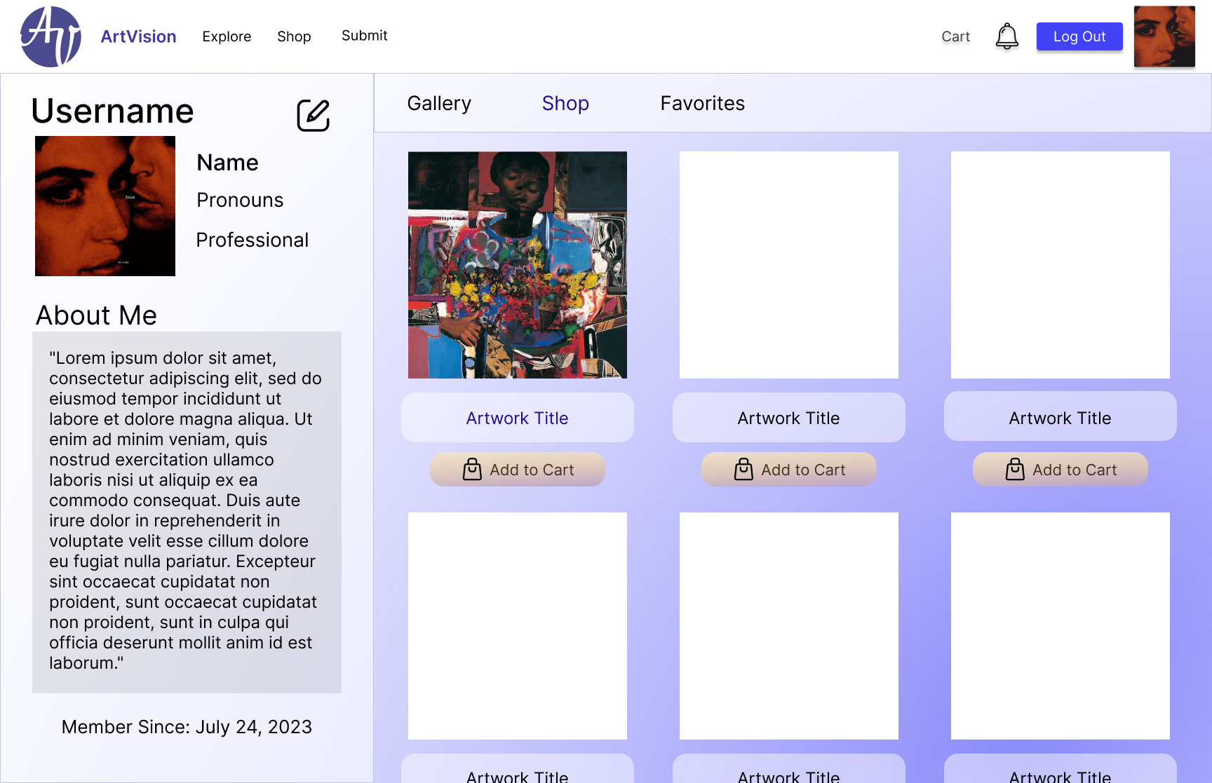  
  
  
  
Submit Art Page**

**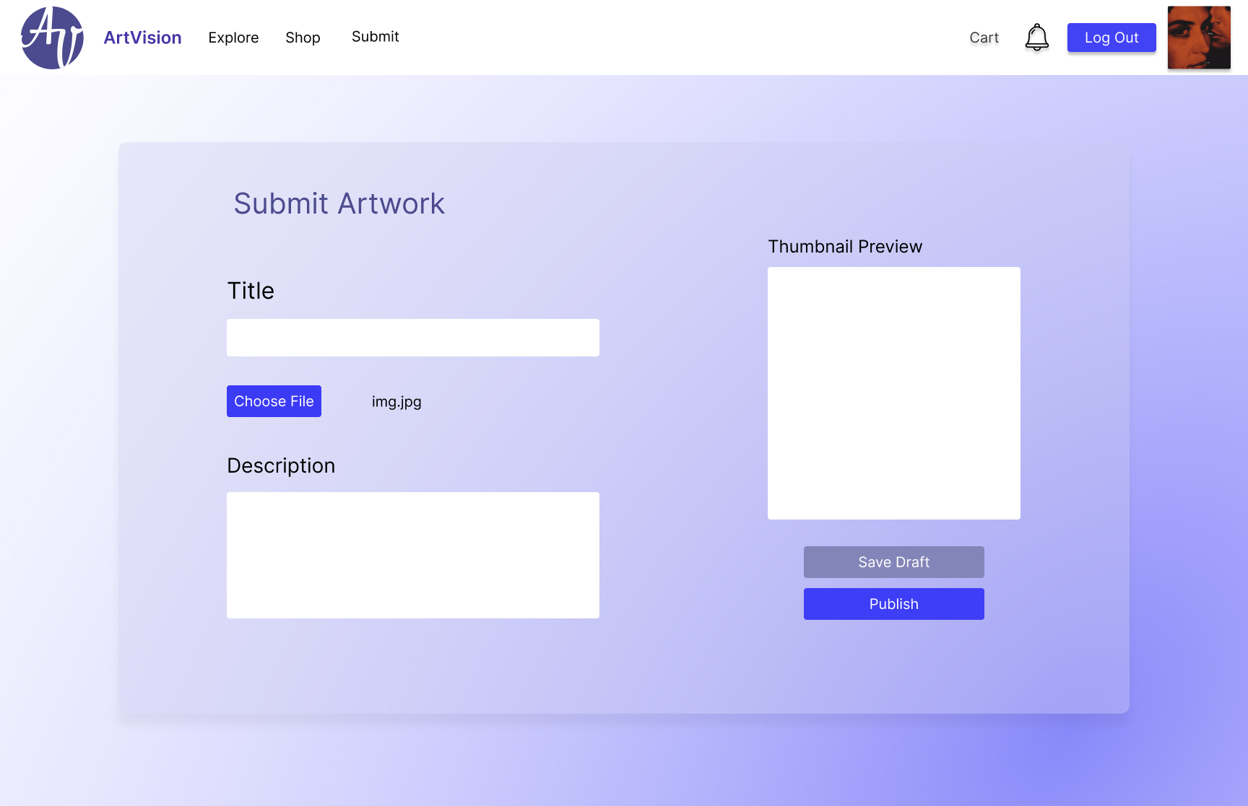  
  
Shop Checkout Page  
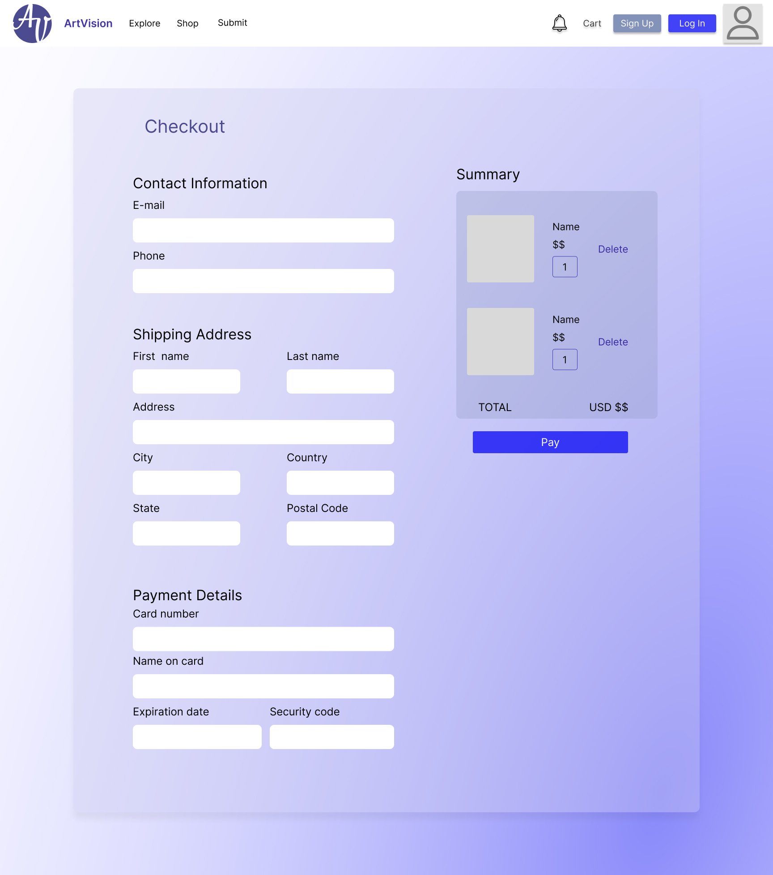**

1. **Technologies:**

The following technologies were carefully chosen to ensure optimal performance and a seamless user experience:

* **Design:** Figma was used for our user interface design process. Its collaborative features allowed for a streamlined approach. The website mockups created in Figma guided our frontend development process, facilitating consistency across our application and ensuring a unified aesthetic by providing reusable design templates.
* **Frontend:** HTML, CSS, and JavaScript—in tandem with the jQuery library and Bootstrap framework—were employed to create an engaging user interface.
* **Backend:** Python was chosen to manage server-side functionality. Initially, we considered Django for the web framework, but we eventually settled on Flask because of its simplicity, flexibility, and fine-grained control over the components of the application. SQLAlchemy was used to facilitate interaction with the database, and Boto3 was employed to interface with AWS.
* **Database:** Initially, we selected PostgreSQL for use as our database system because of its comprehensive feature set and powerful SQL capabilities. However, as the project progressed, we realized the benefits of using SQLAlchemy with Flask_SQLAlchemy. This combination offered a much more seamless integration with our Python-based backend. SQLAlchemy abstracted low-level SQL commands and provided a high-level, pythonic interface to interact with our database. This switch not only increased our development speed but also greatly improved the maintainability and scalability of our application.
* **Cloud:** We decided to use Amazon Web Services (AWS) for hosting and managing user-submitted images. Specifically, we employed Boto3, the AWS SDK for Python, to create, configure, and manage an Amazon Simple Storage Service (Amazon S3) bucket. This not only allowed us to leverage AWS's powerful infrastructure but also ensured seamless integration with our Python-based backend. AWS also offers top-notch security measures, ensuring the safety and integrity of our user data.

1. **Team Contributions**

Each member of our team demonstrated remarkable flexibility and a readiness to assume different roles as needed. Our collaborative efforts and individual initiatives were equally crucial to the success of ArtVision’s development. A detailed overview of each team member's contributions is as follows:

* **Obie Carnathan:** Obie was our resident cloud technology maestro. While he made significant contributions in back-end development and database management, his most impactful role was the integration of Amazon Web Services (AWS). Obie also demonstrated exceptional problem-solving skills when the team faced challenges with GitHub. His ability to resolve complex merge conflicts and other issues was critical to our team's ability to maintain a smooth development process.
* **Daniela Chavez:** Daniela collaborated with Katrina in creating the website’s user interface design template in Figma. She was involved in both front-end and back-end development as well as database management and debugging, playing a significant role in the introduction of several key website functionalities. Her efforts were particularly noteworthy in implementing the art submission pages, checkout page and enhancing users’ overall experience.
* **Katrina Murrell:** Katrina demonstrated her design prowess by spearheading creation of the website’s user interface design template in Figma. She worked hand in hand with Jesus, Daniela, and Obie on both front-end and back-end development with significant contributions to database management, debugging and code revamping, and new feature implementation. Selected contributions of note include comment functionality, a robust search feature, and account deletion. These multifaceted contributions greatly enhanced the user experience, underlining her valuable role within the team.
* **Jesus Zubia:** Jesus was instrumental in both front-end and back-end development of the platform, demonstrating his proficiency in JavaScript and Python. Besides building a user-friendly interface and efficient server-side functionalities, he also spearheaded the design and management of ArtVision’s database architecture, ensuring smooth data retrieval within the platform. Jesus also contributed significantly to the efficiency of our team outside of development by keeping extensive meeting notes and drafting our final report.

1. **Results**

* **HTML:**
  + **Static:**
    - **css:**
      * **Profile.css:**
      * **Purchase.css:**
      * **registrationstyles.css:**
    - **js:**
    - **env.py:**

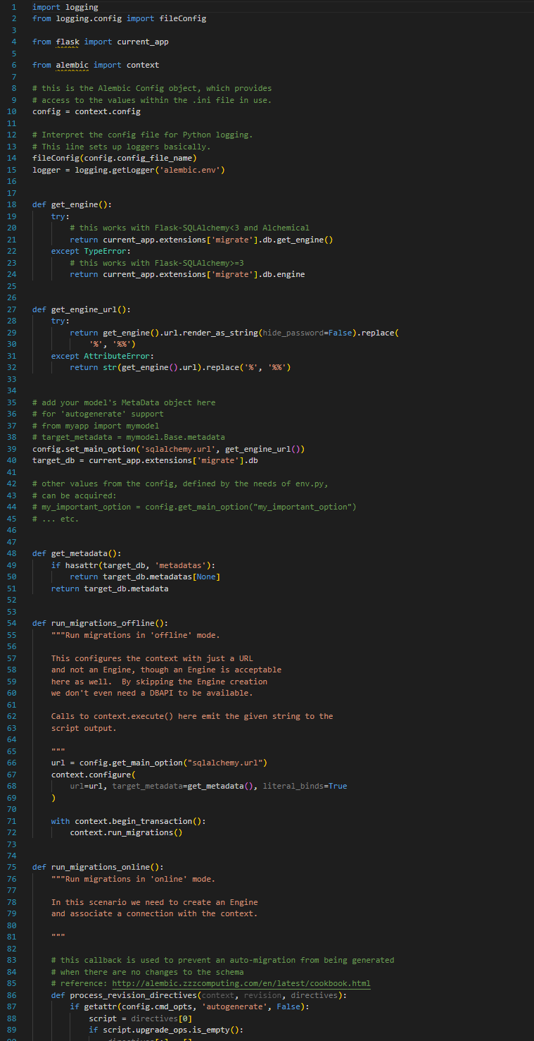

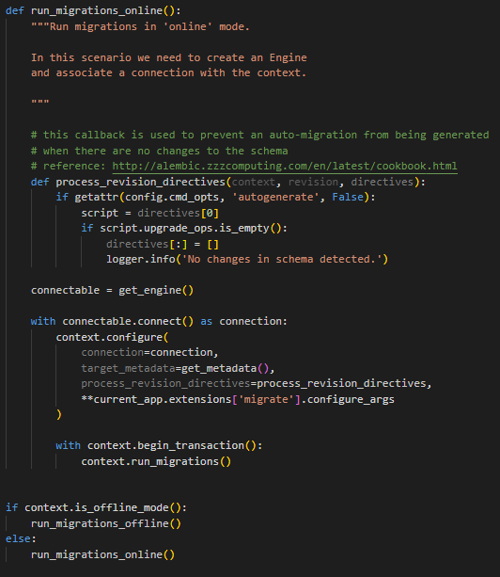

* + **Templates:**
    - **artworkDetails.html:**

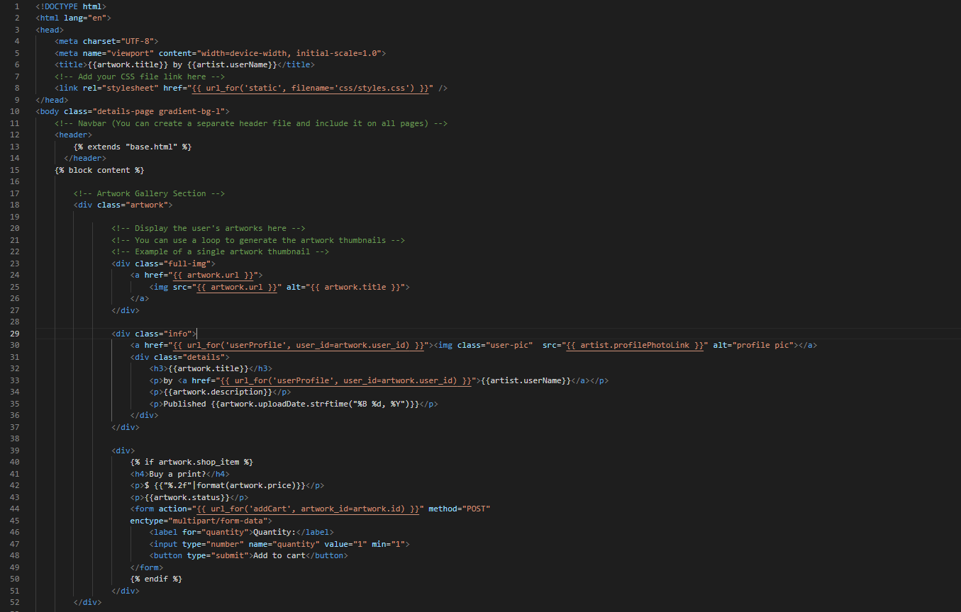

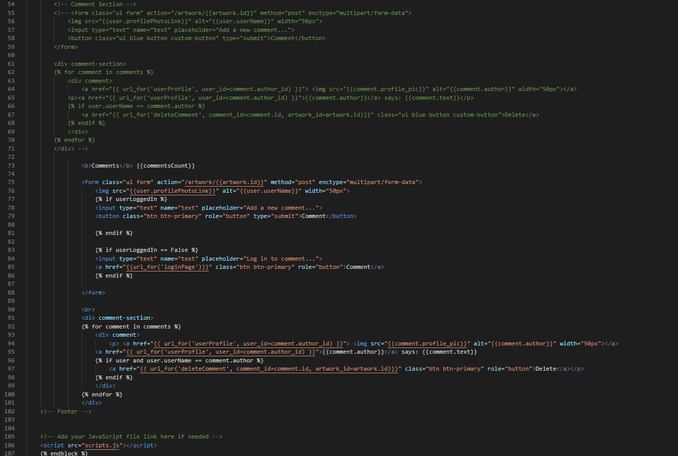

* + - **Base.html:**

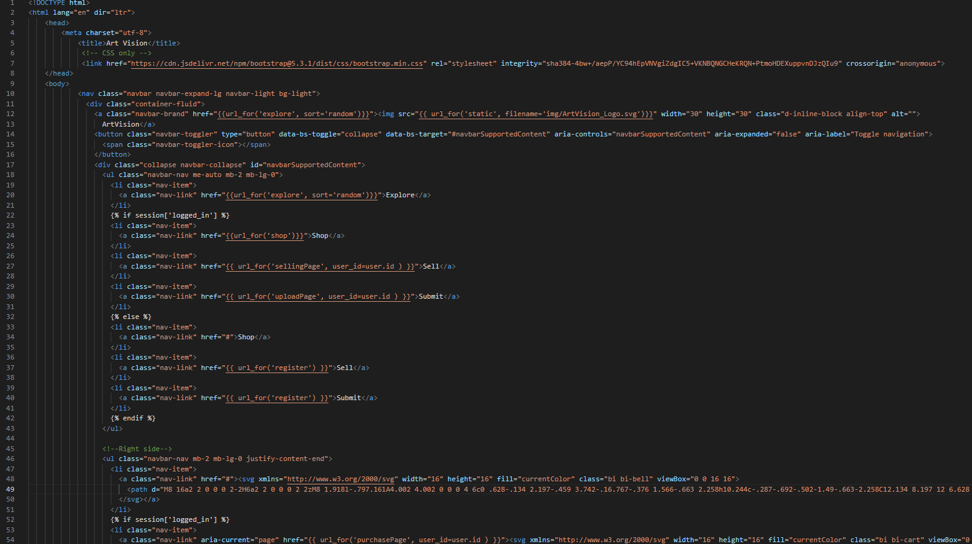

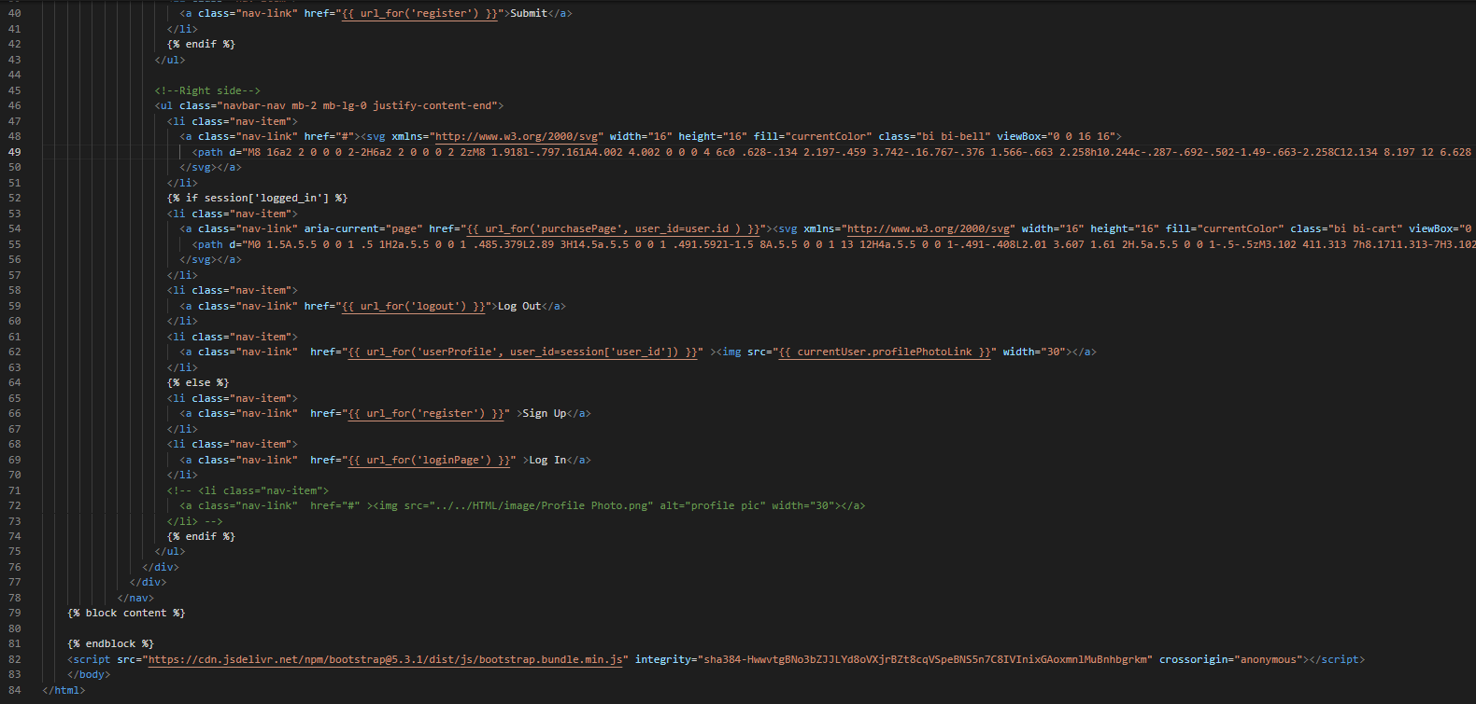

* + - **deleteArt.html:**

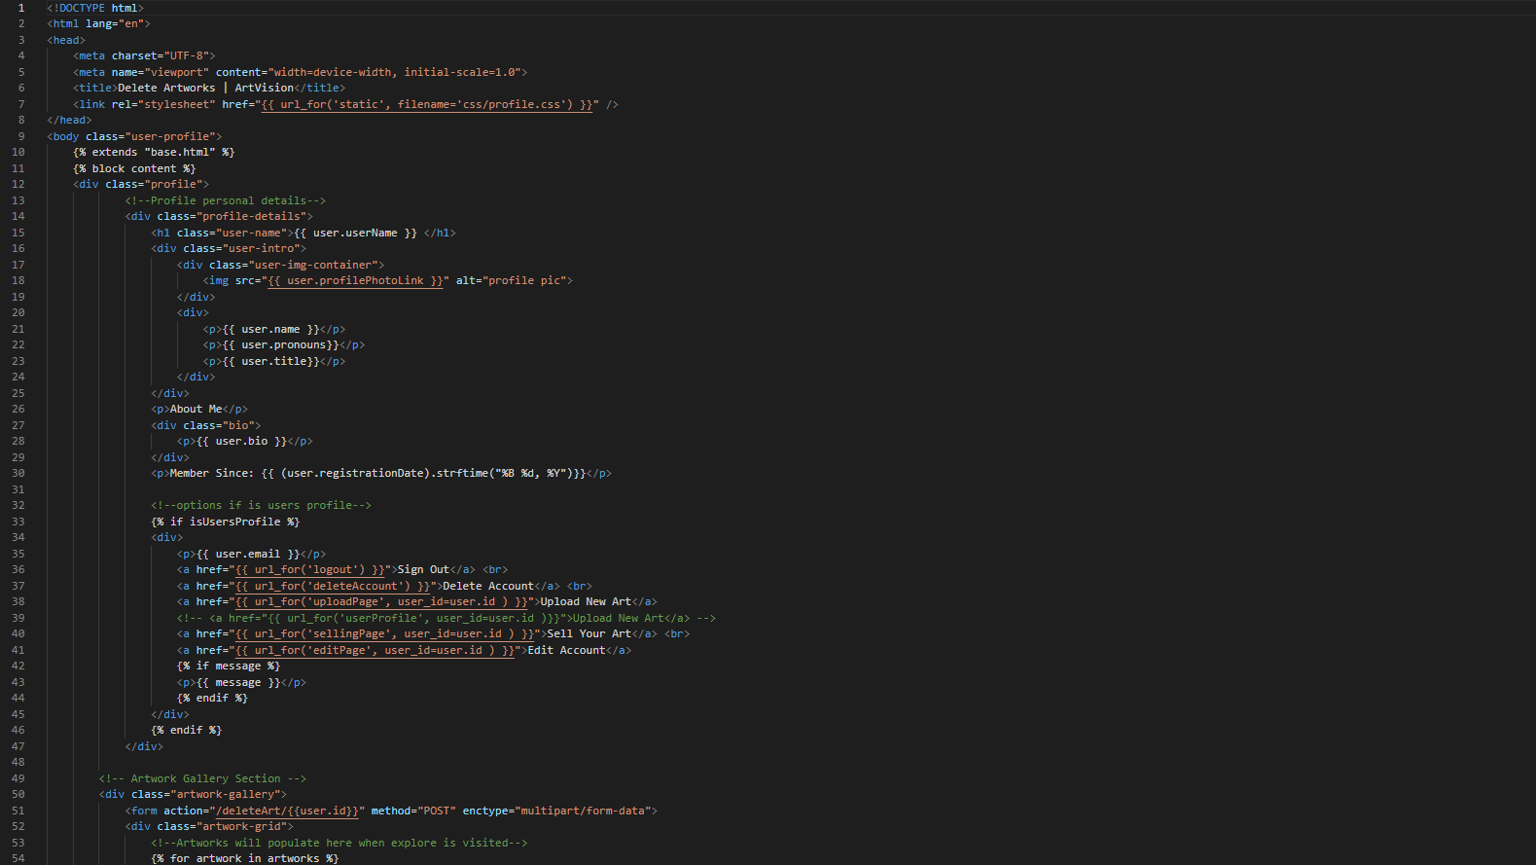

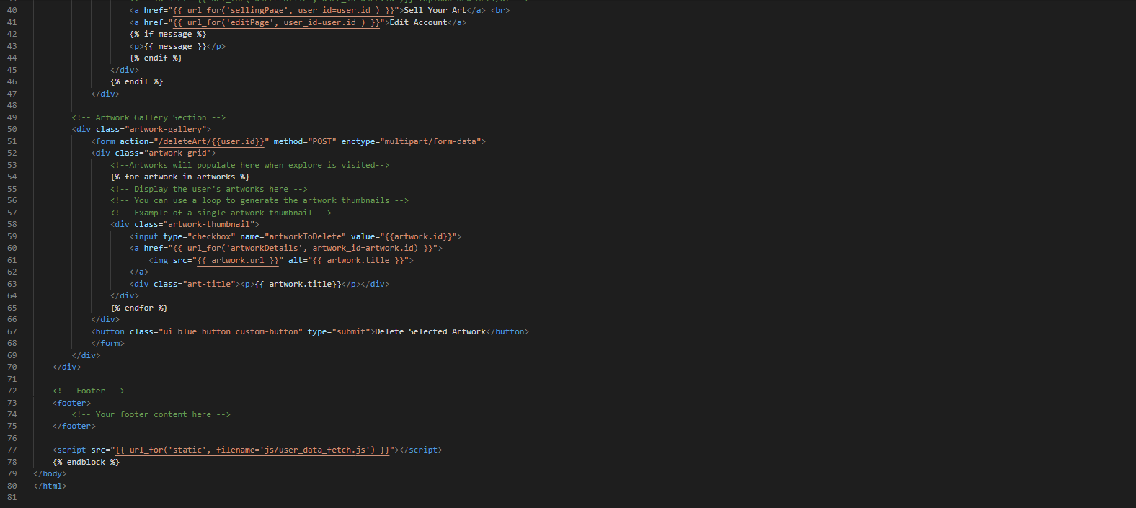

* + - **Error404.html:**

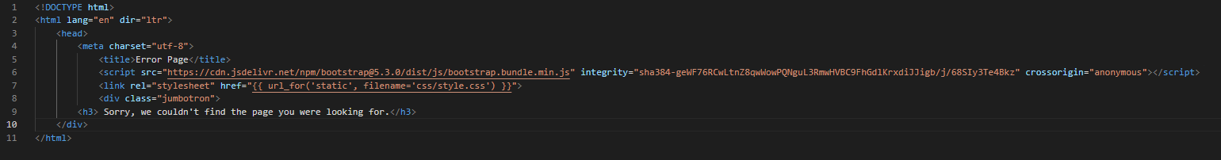

* + - **Homepage.html:**

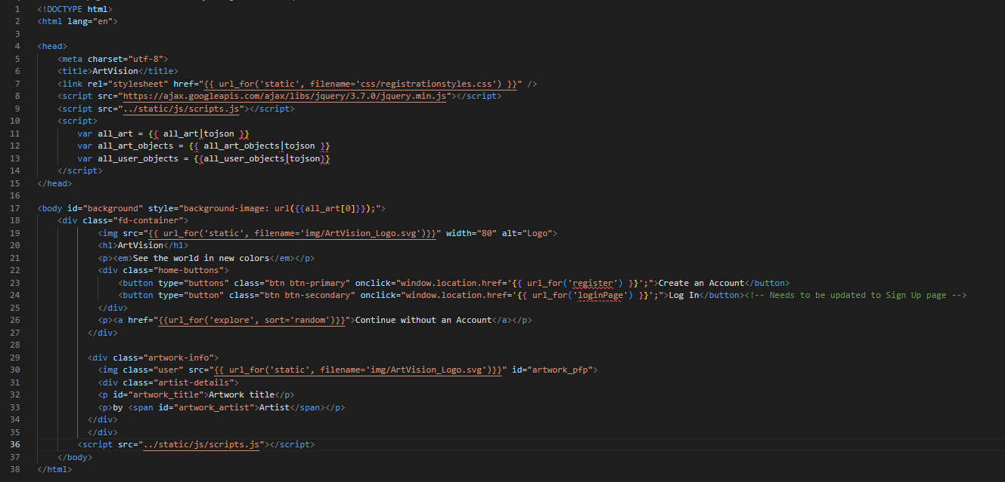

* + - **loginPage.html:**

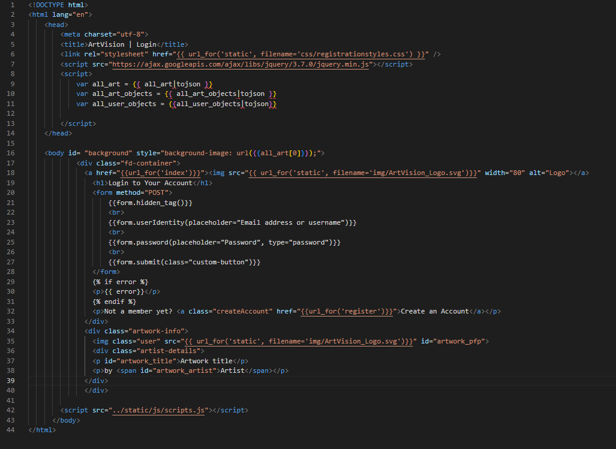

* + - **Purchase.html:**

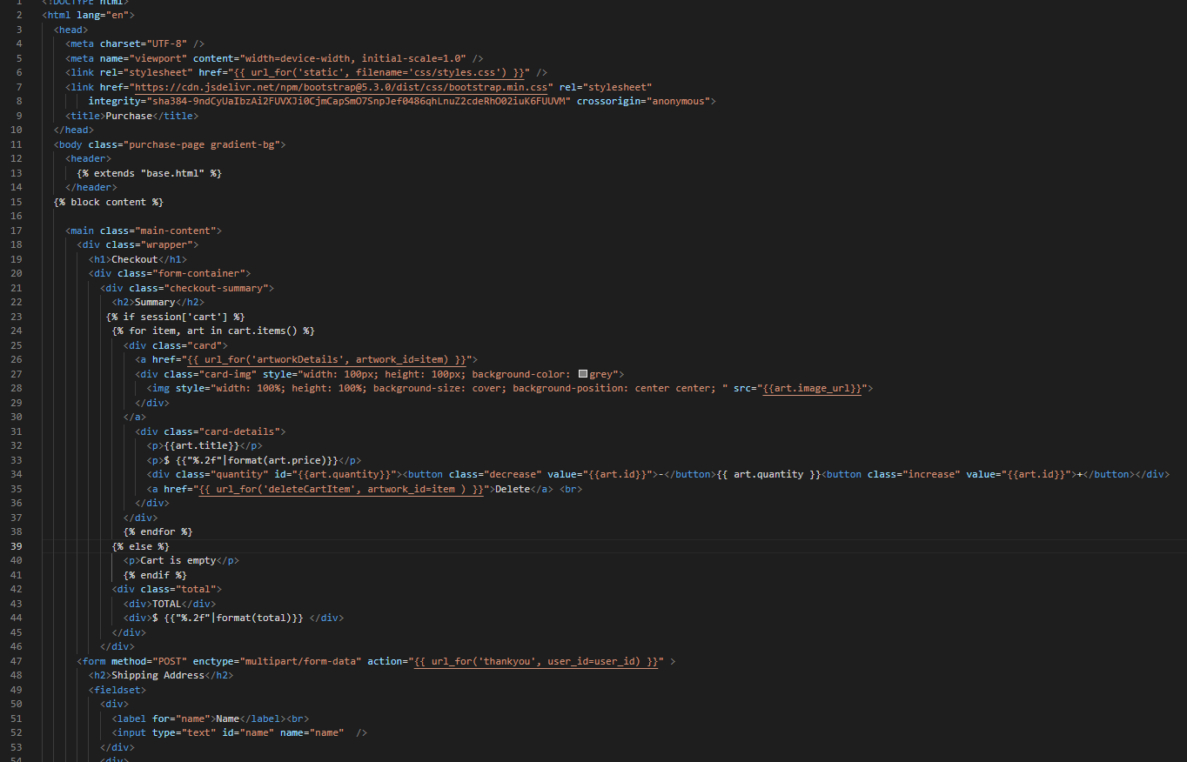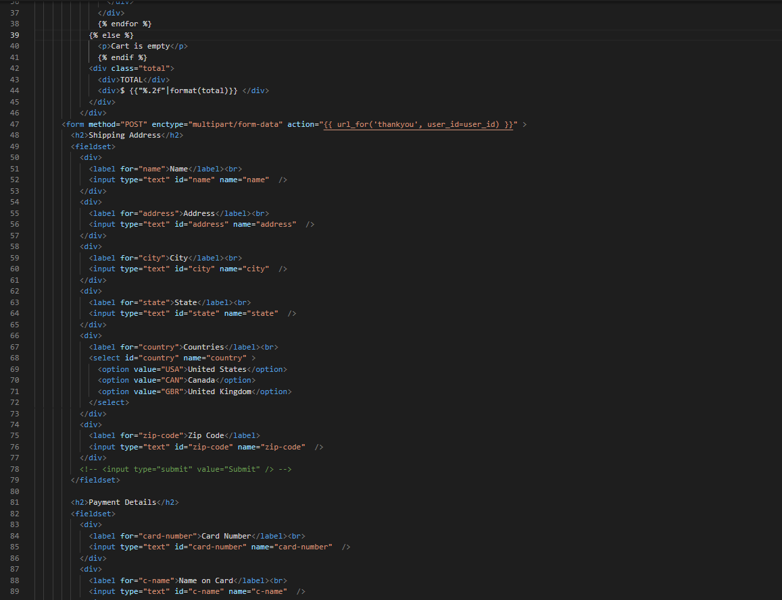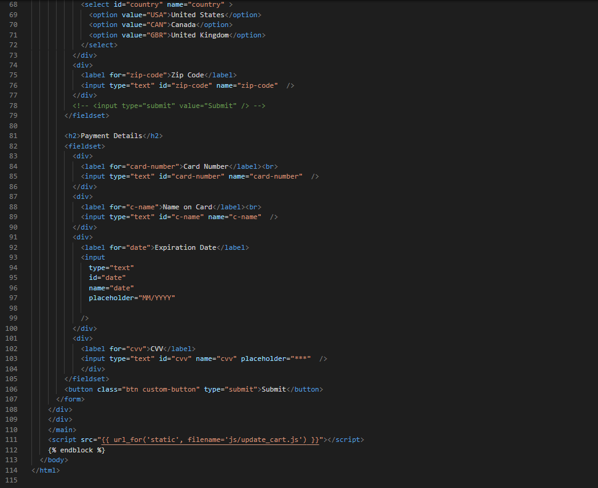

* + - **Register.html**

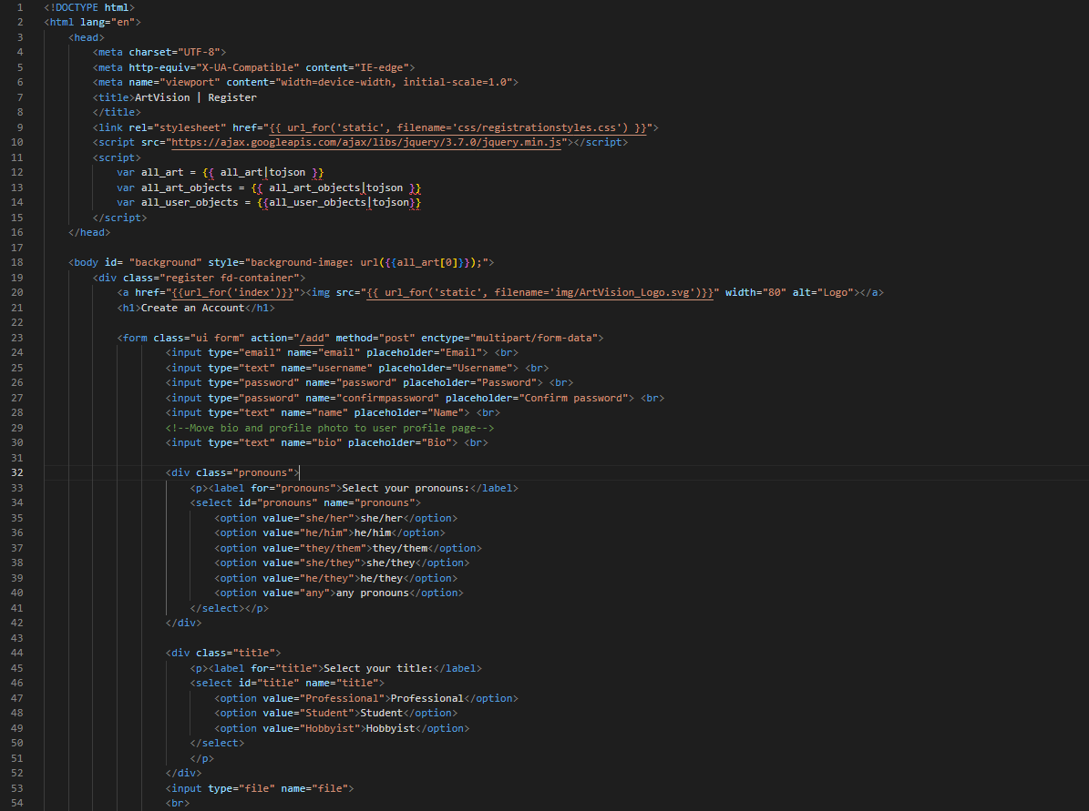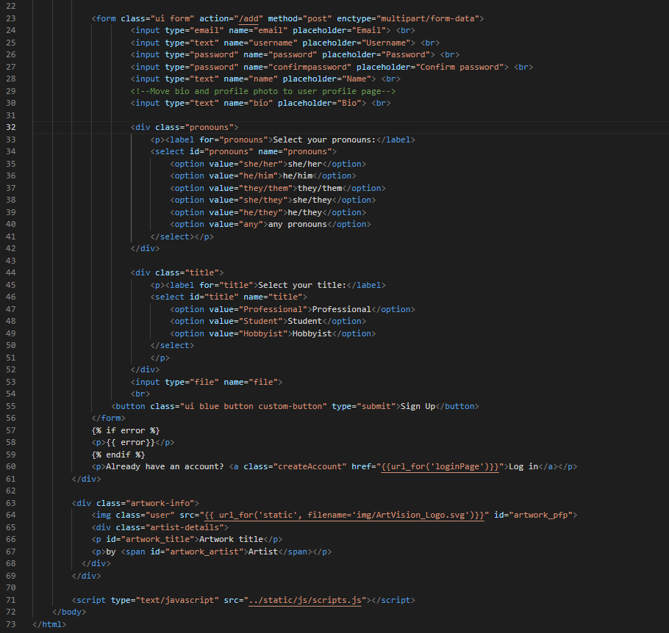

* + - **Selling.html**

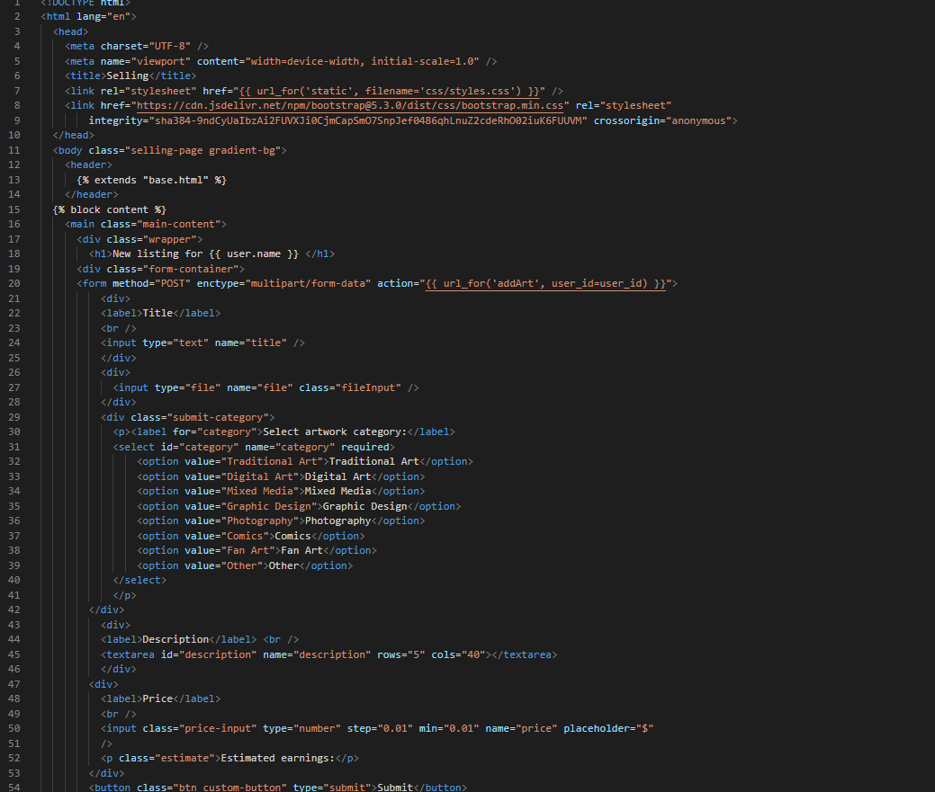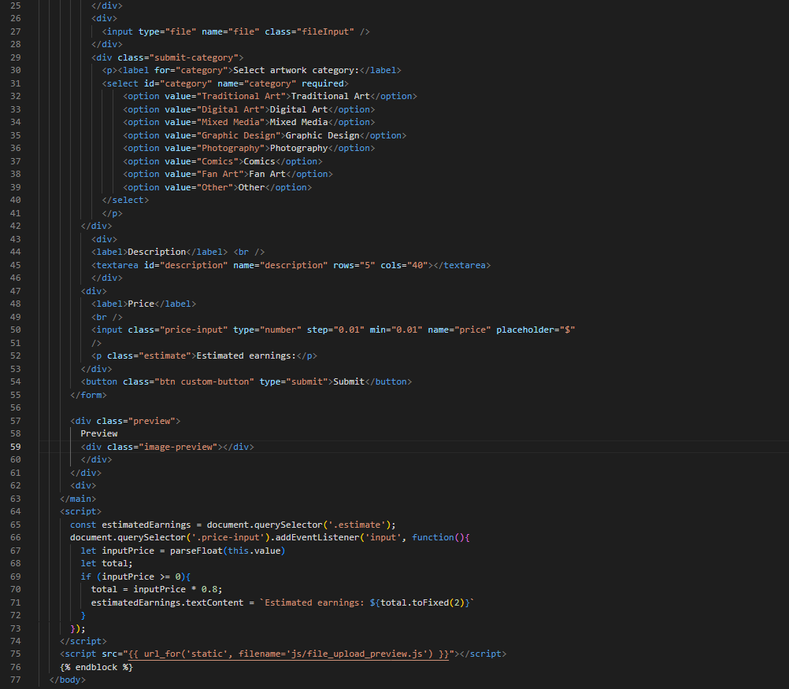

* + - **Shop.html**

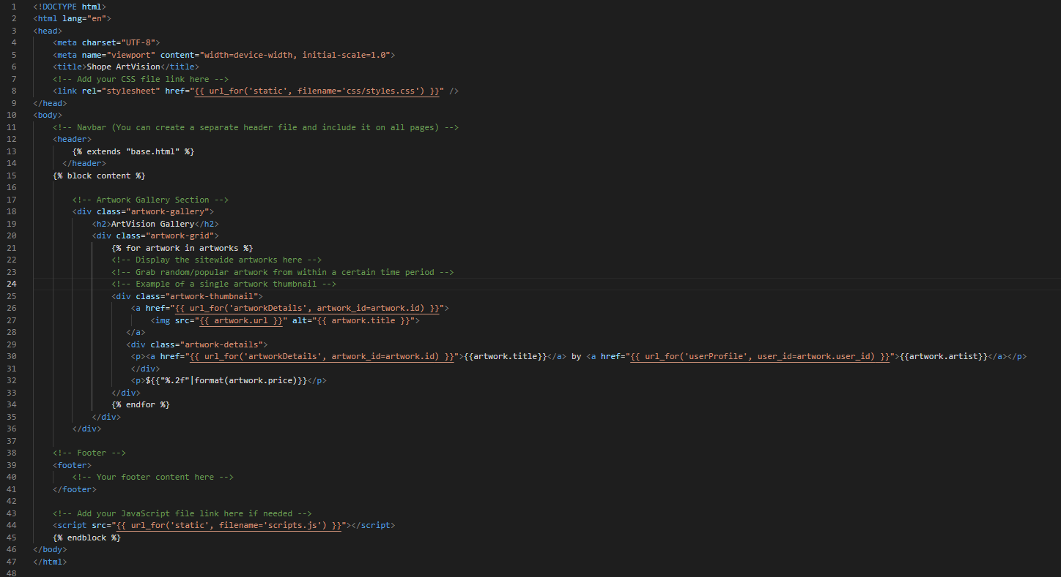

* + - **Thankyou.html**

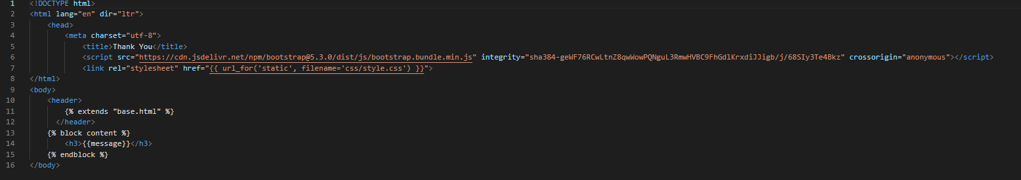

* + - **Upload.html**

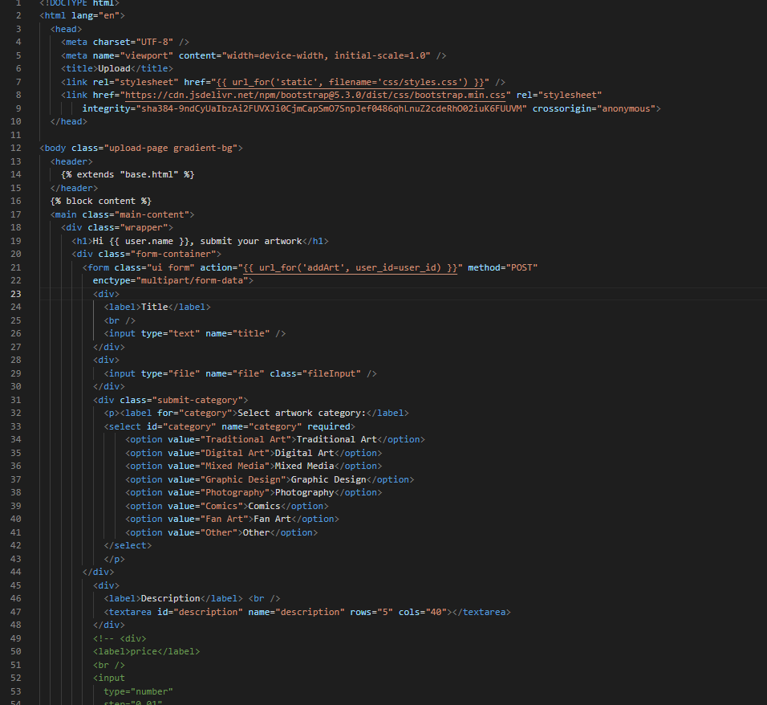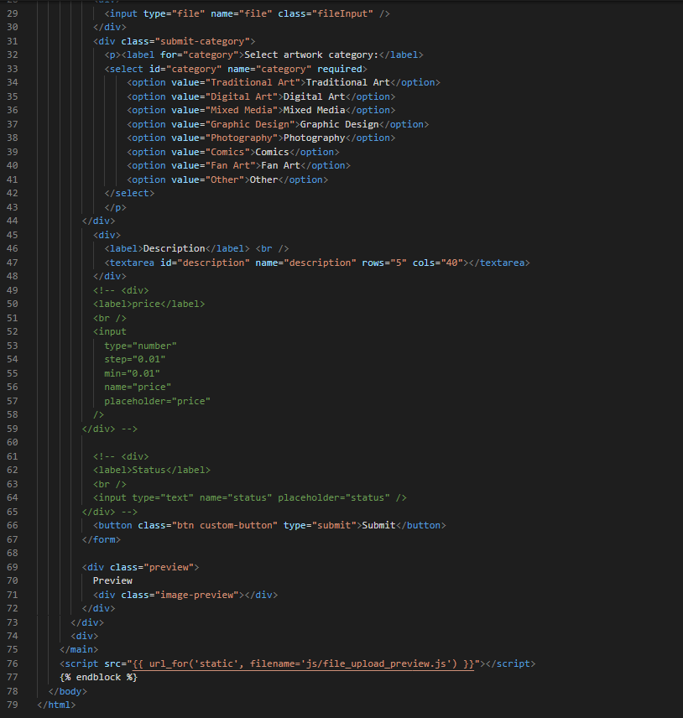

* + - **userProfile.html**

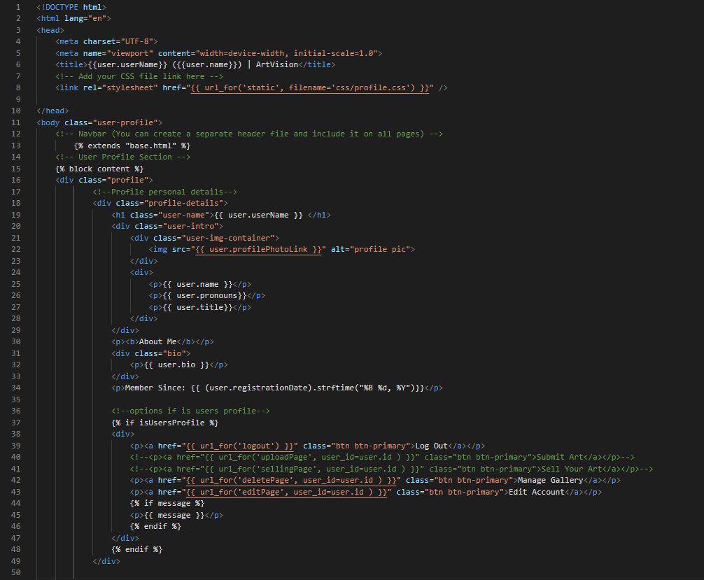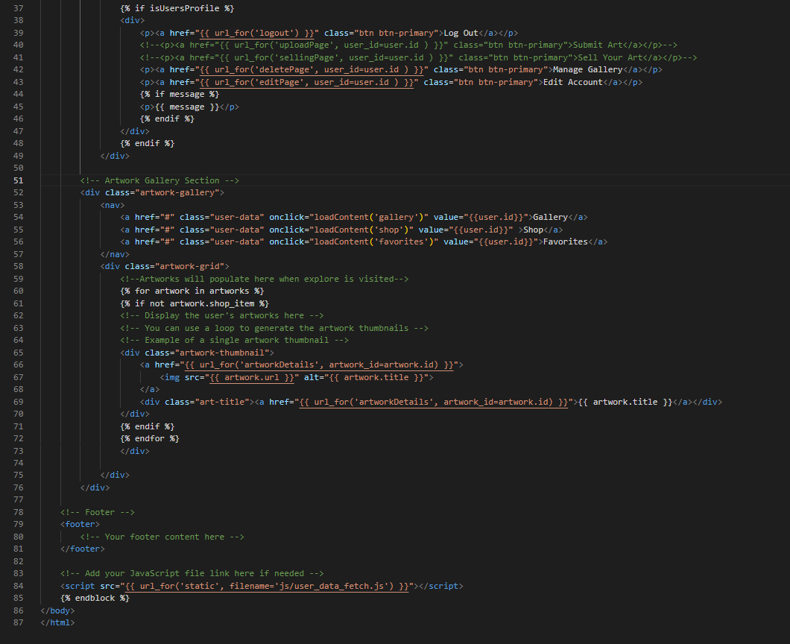

* + **Crud.py:**

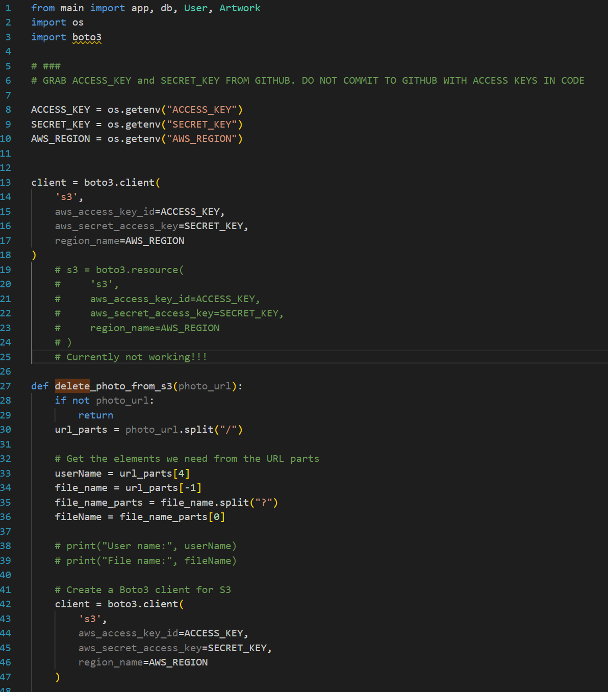

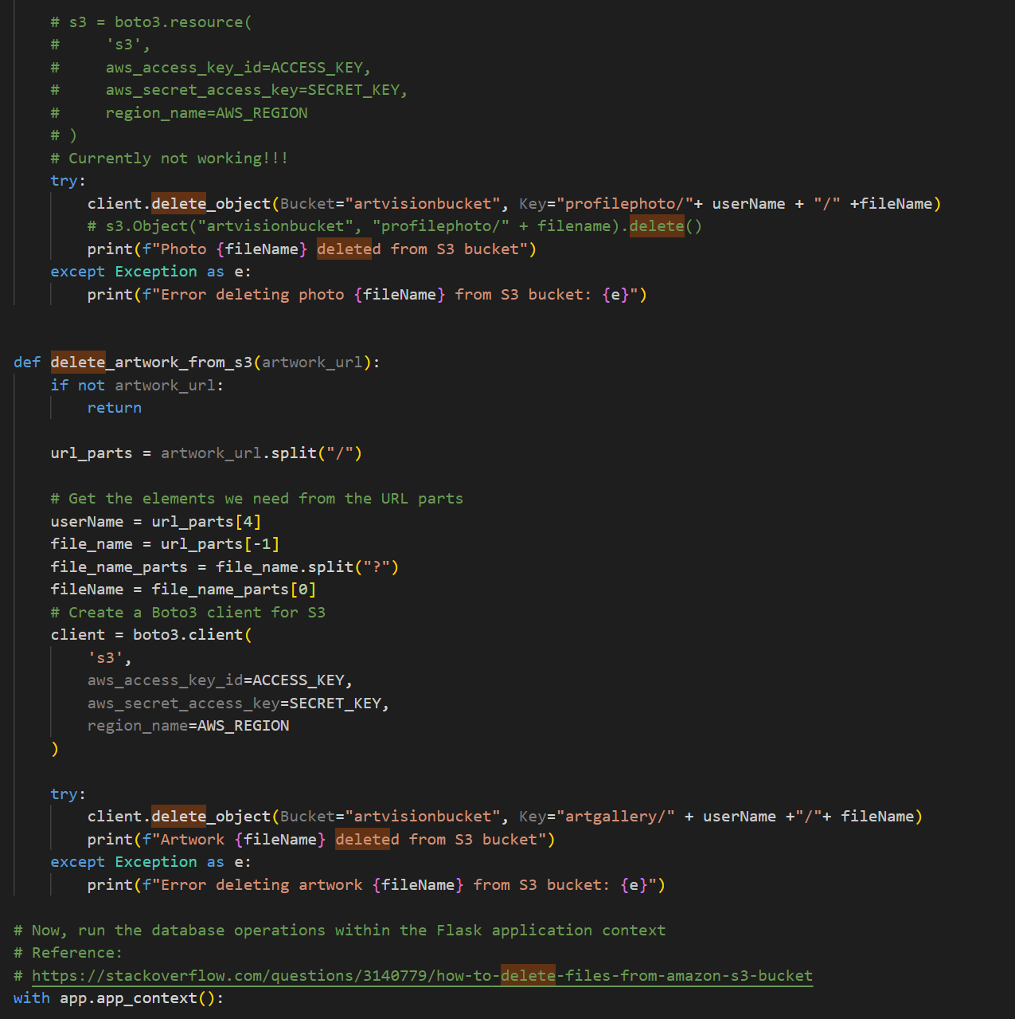

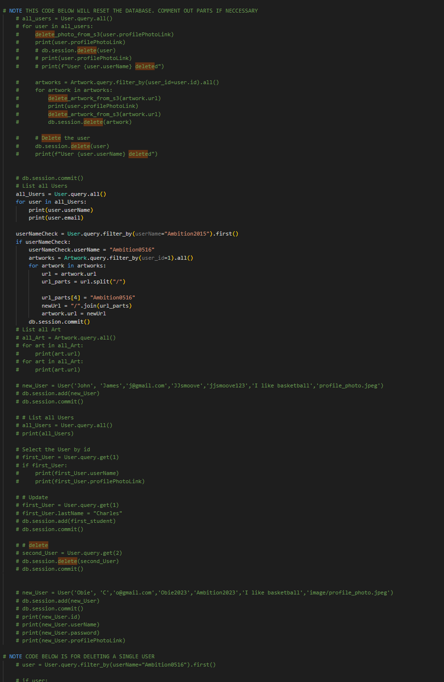

* + **Main.py**

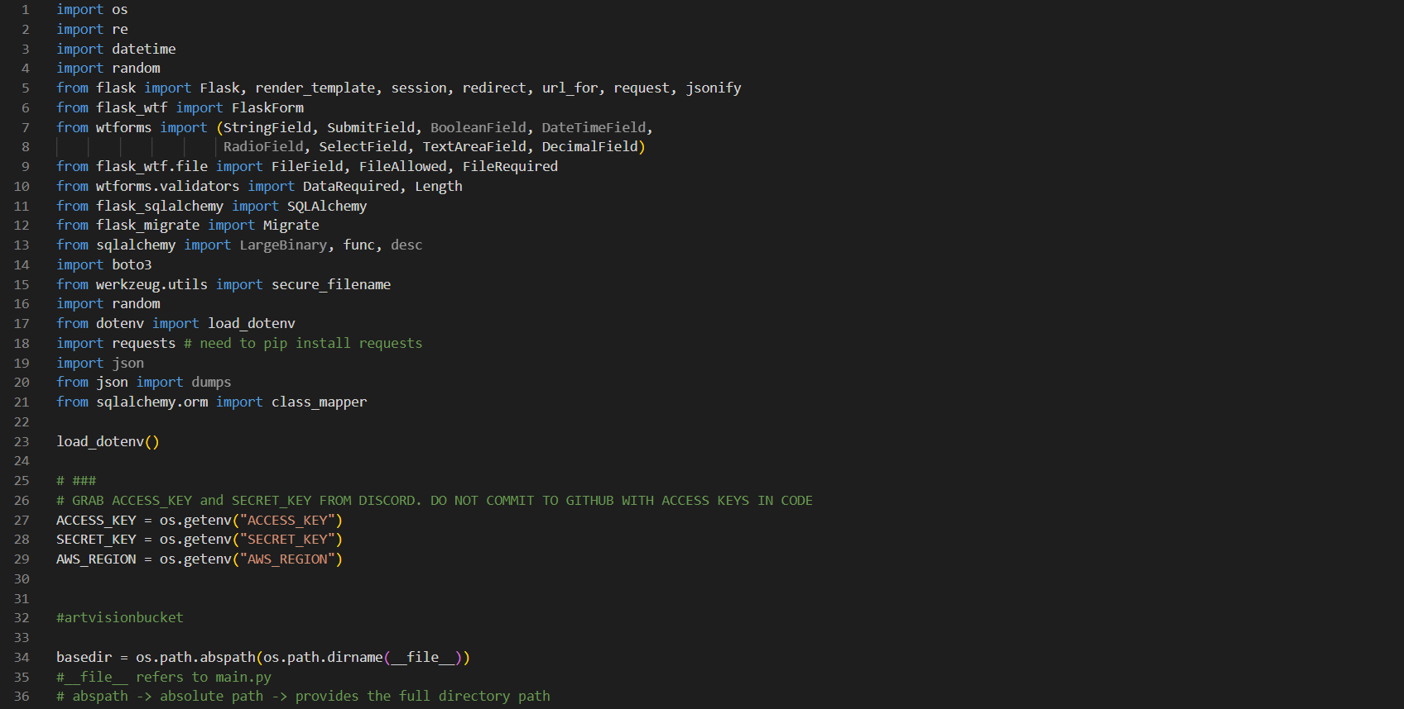

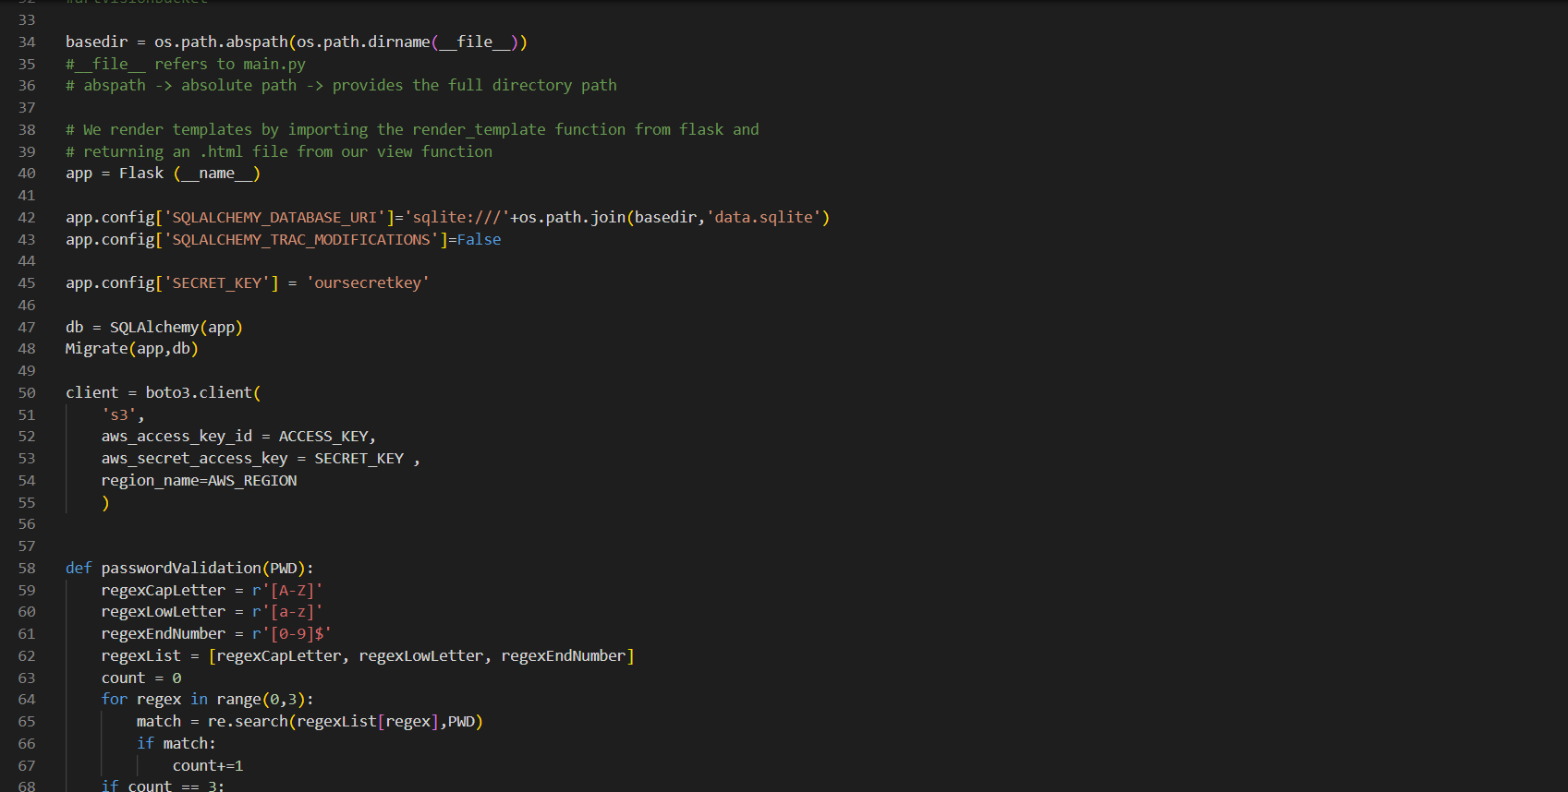

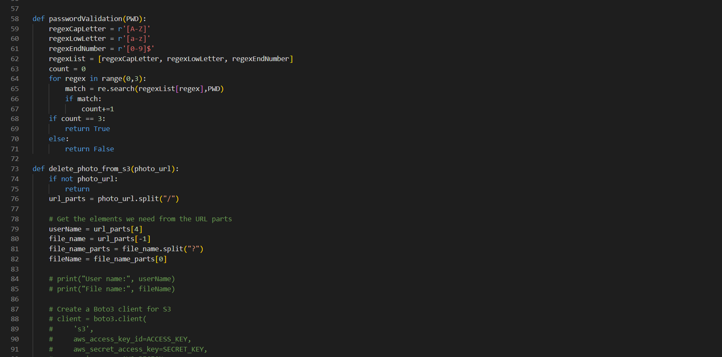

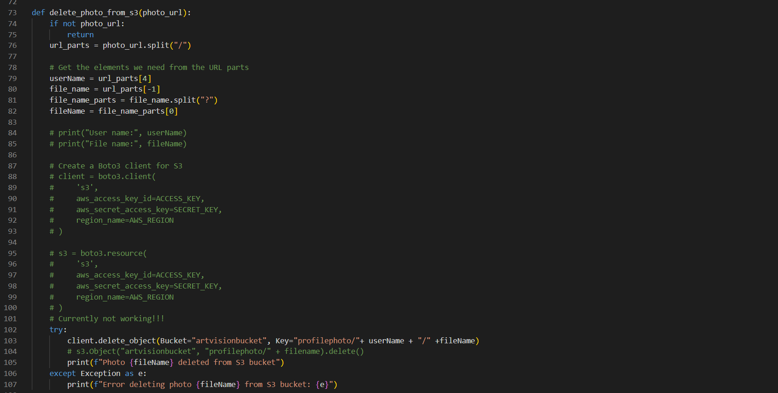

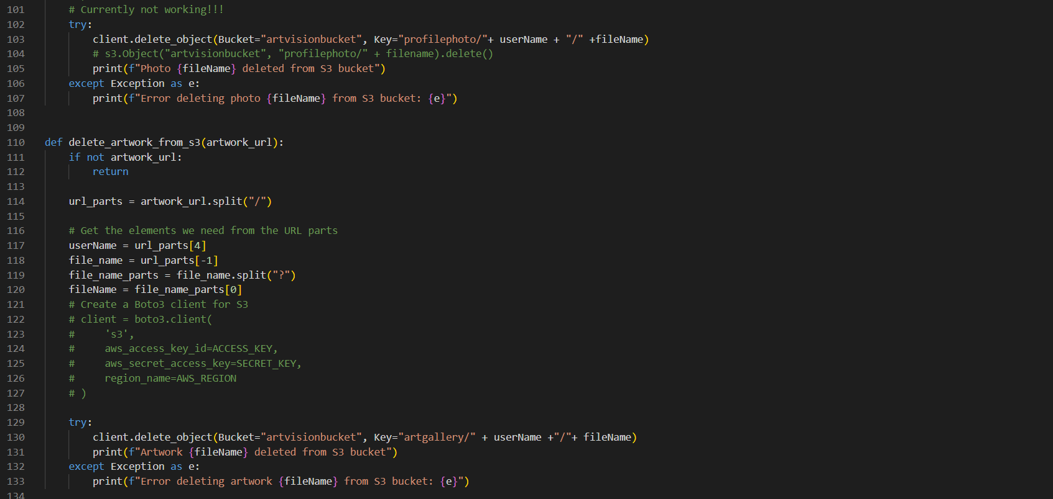

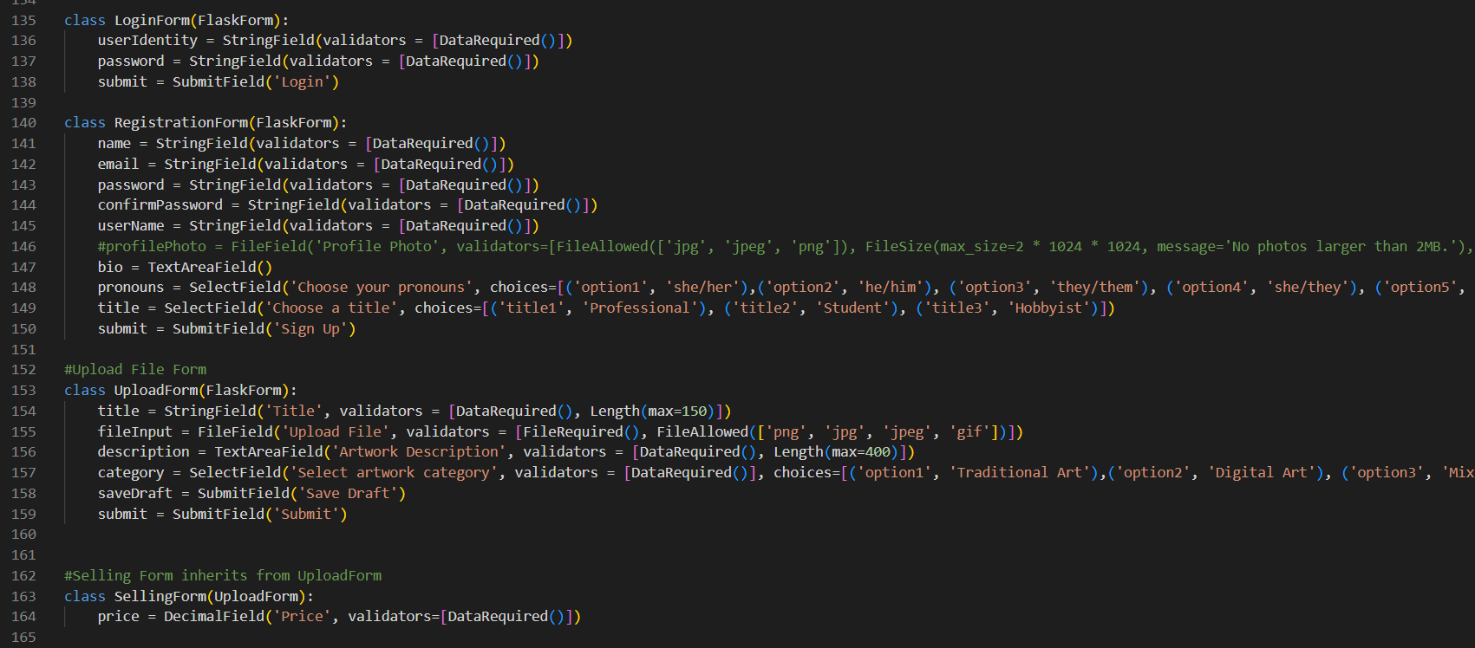

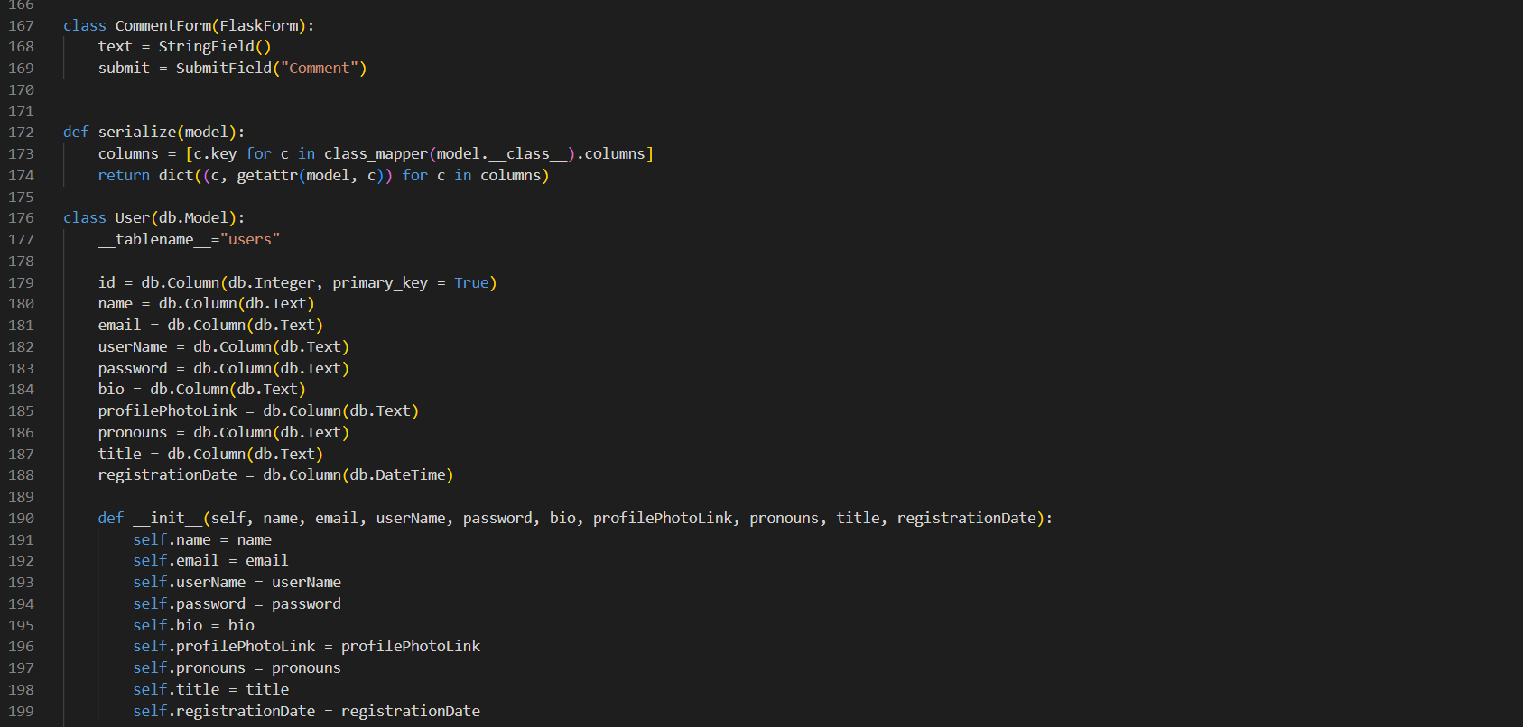

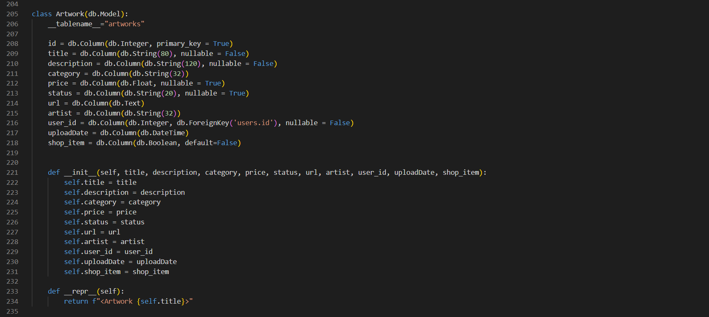

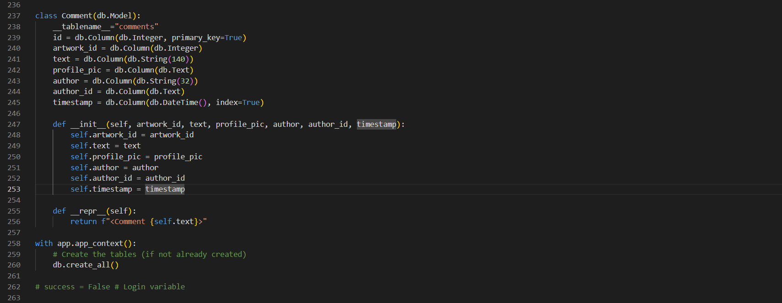

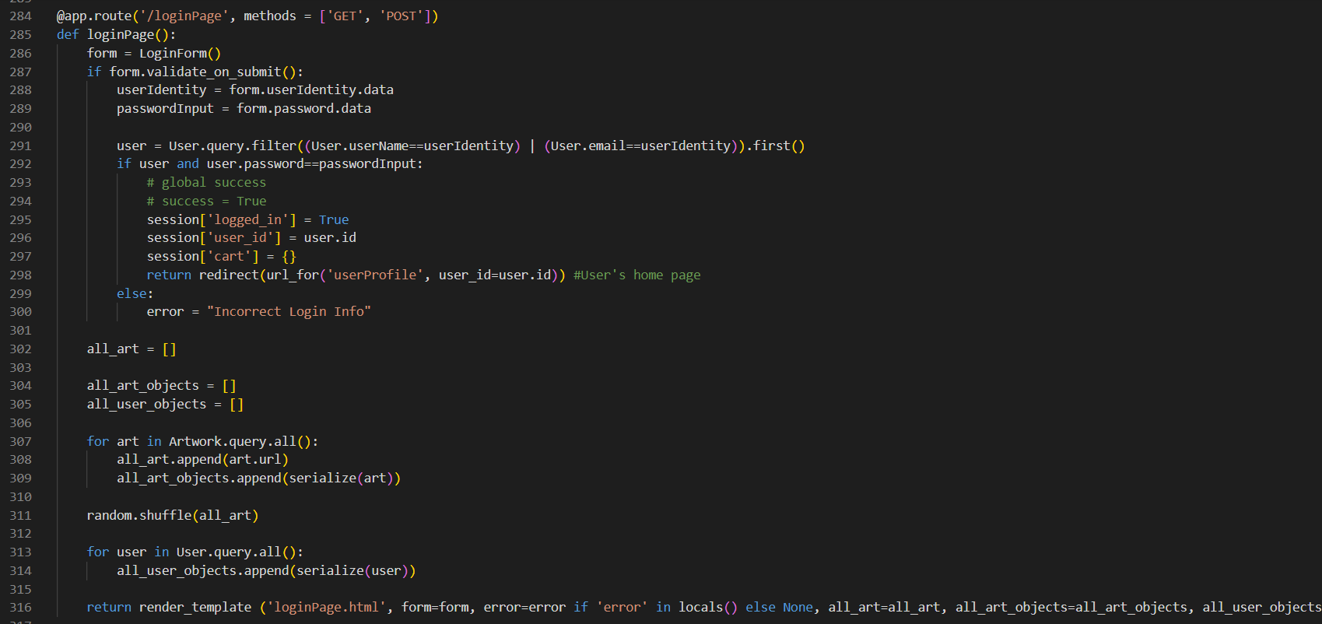

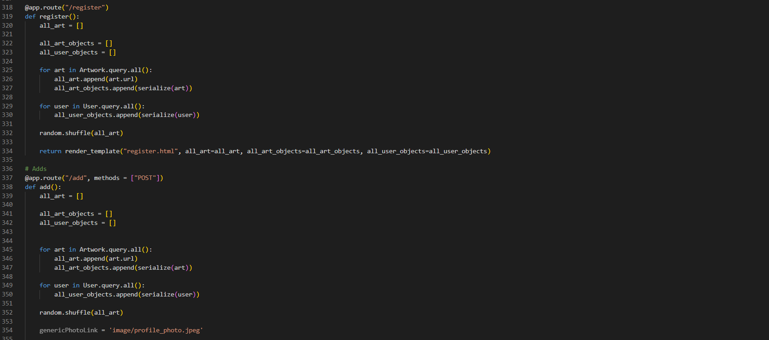

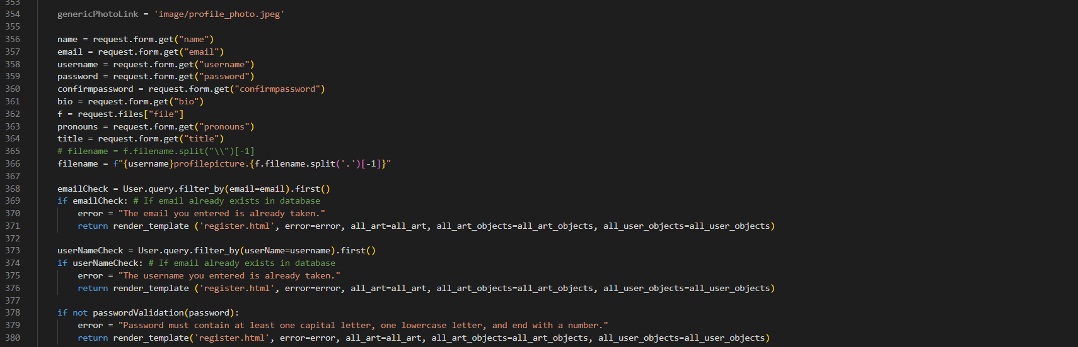

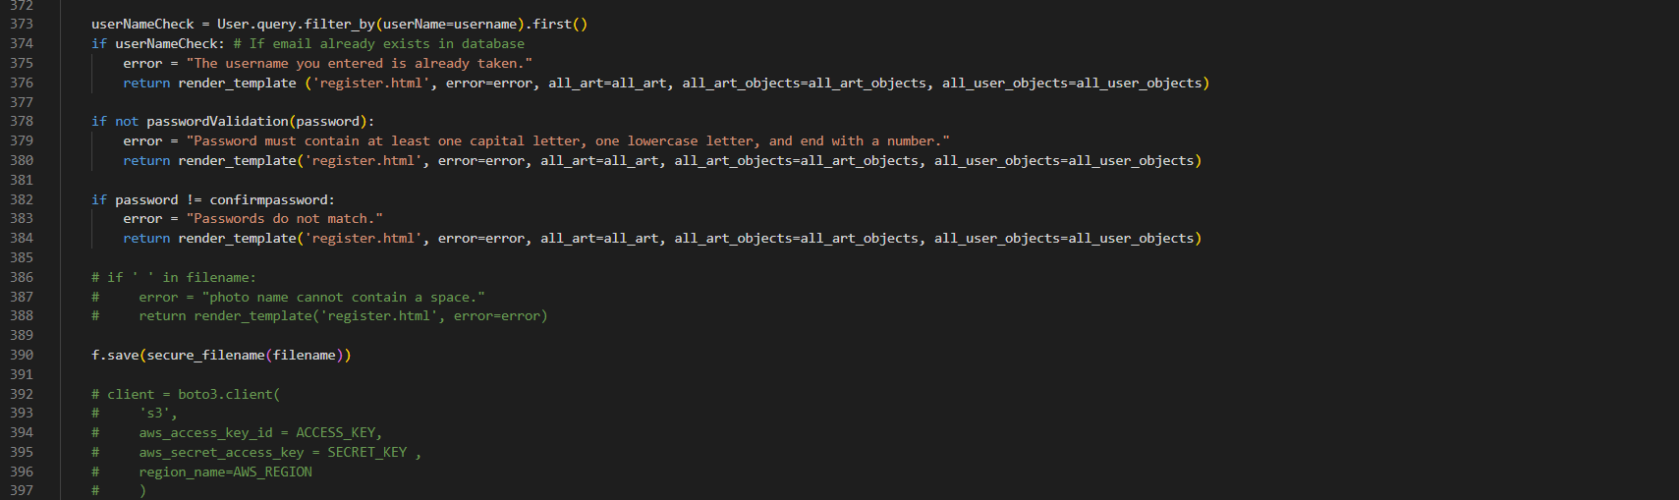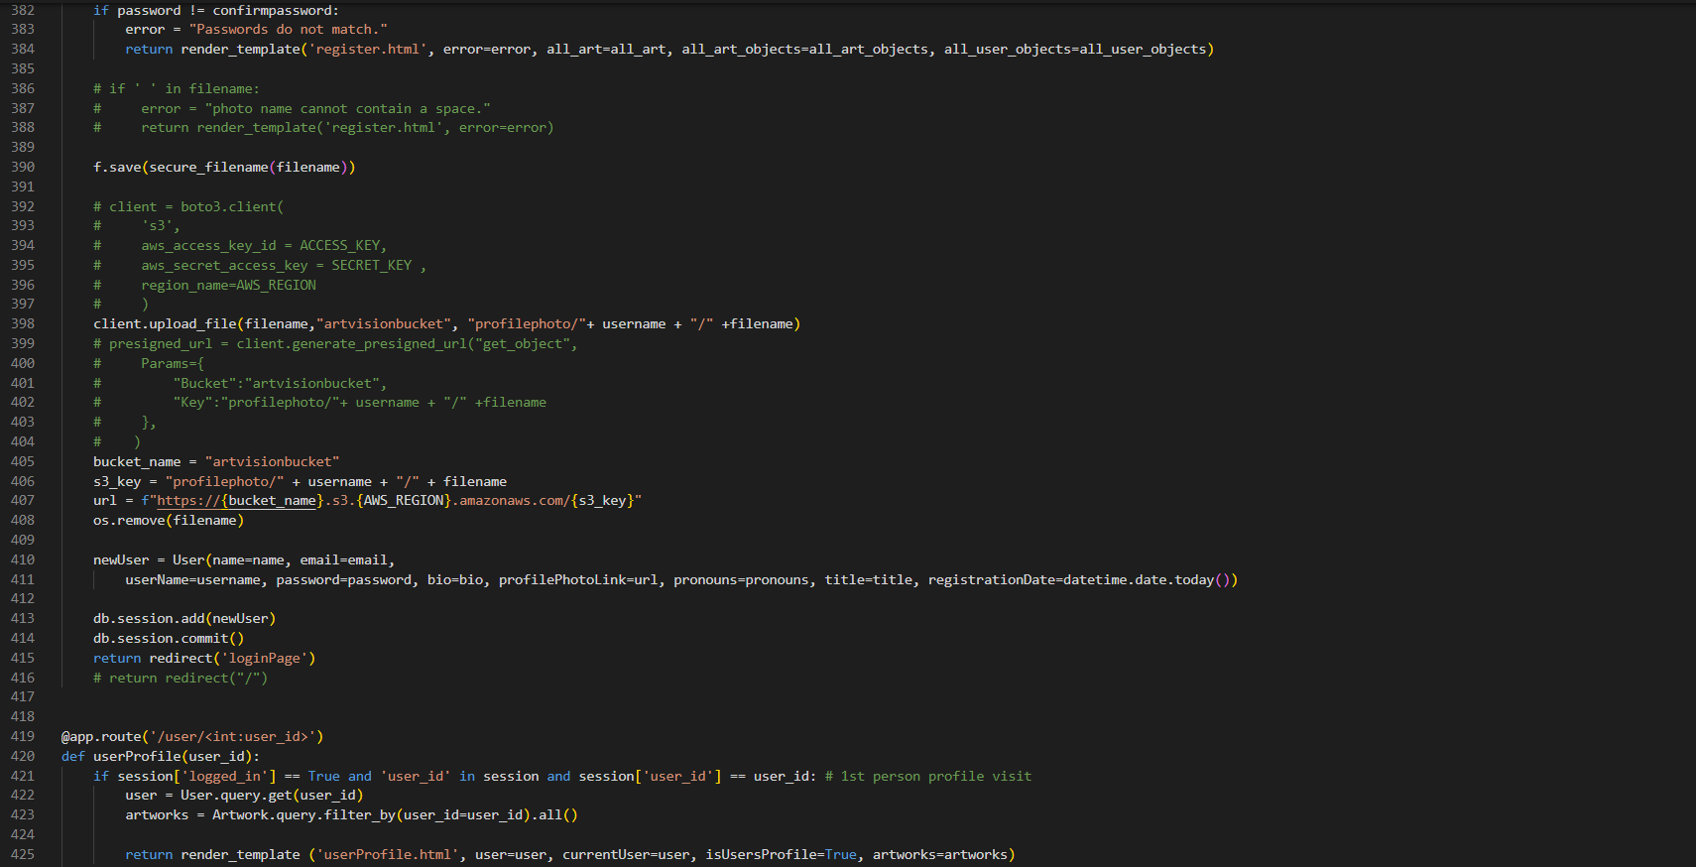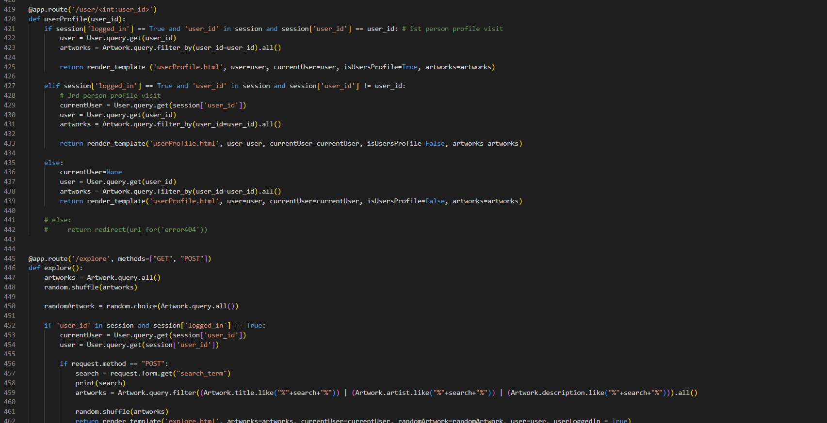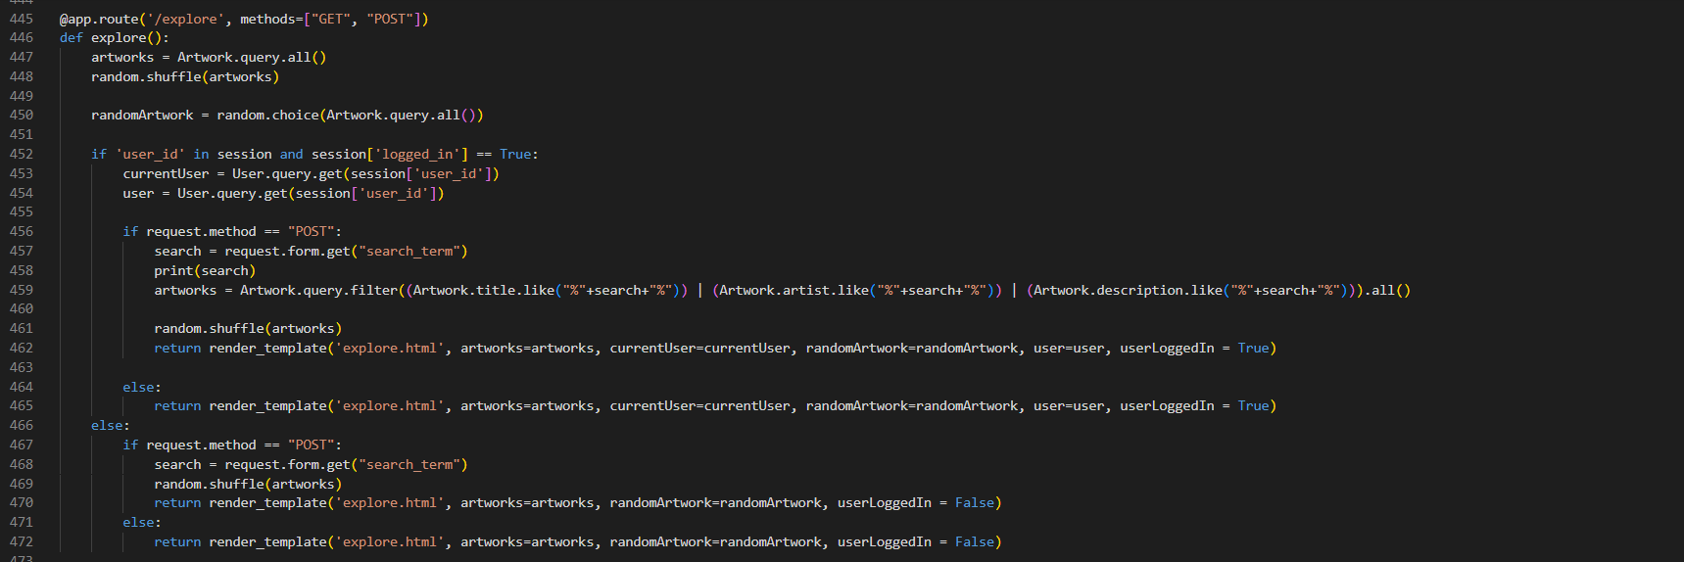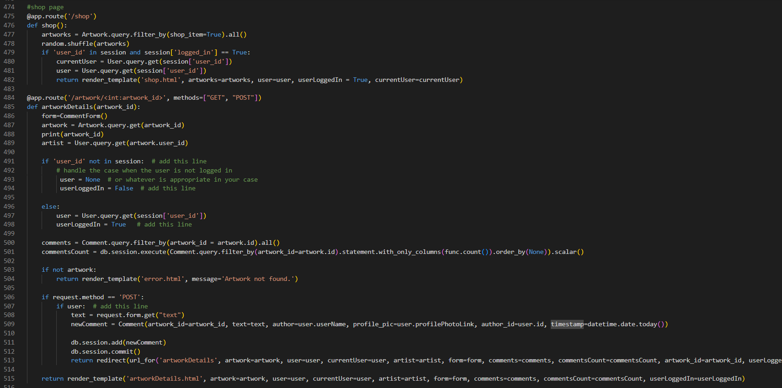

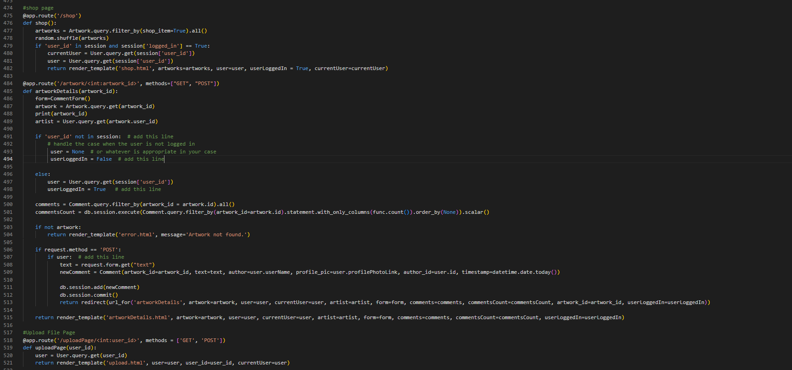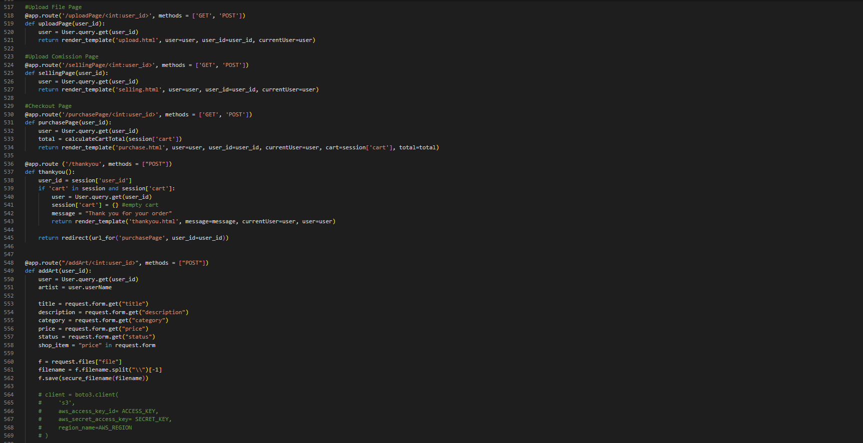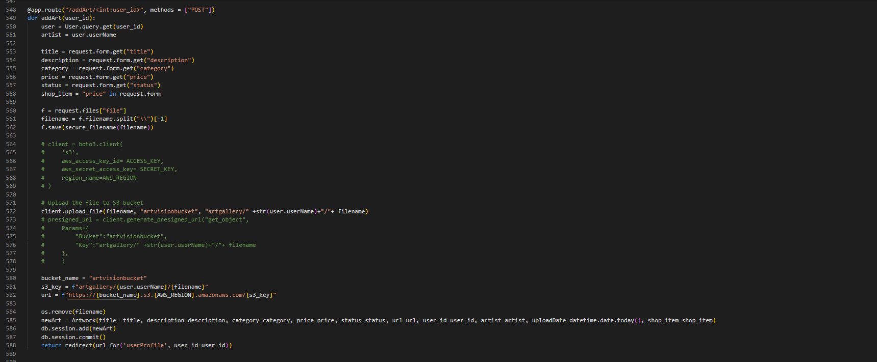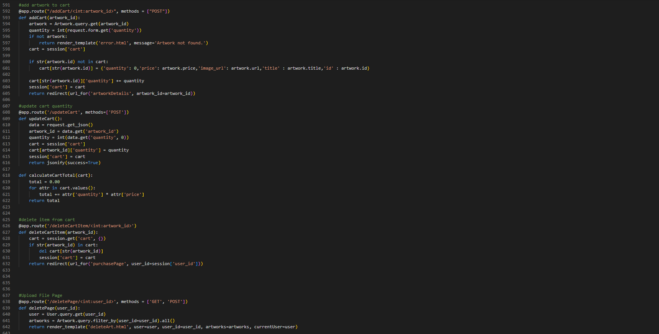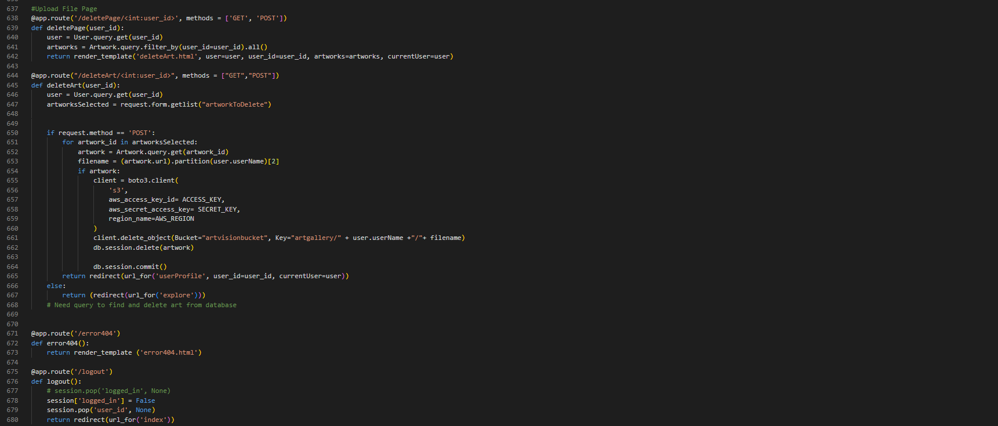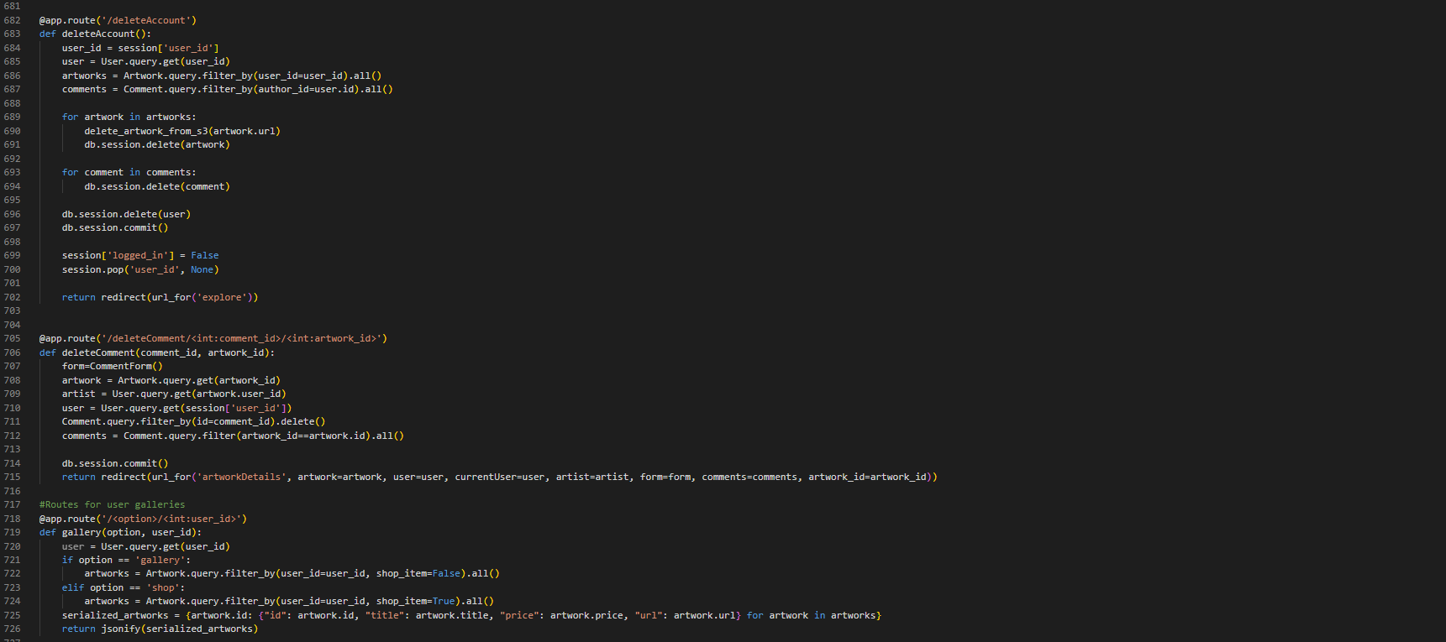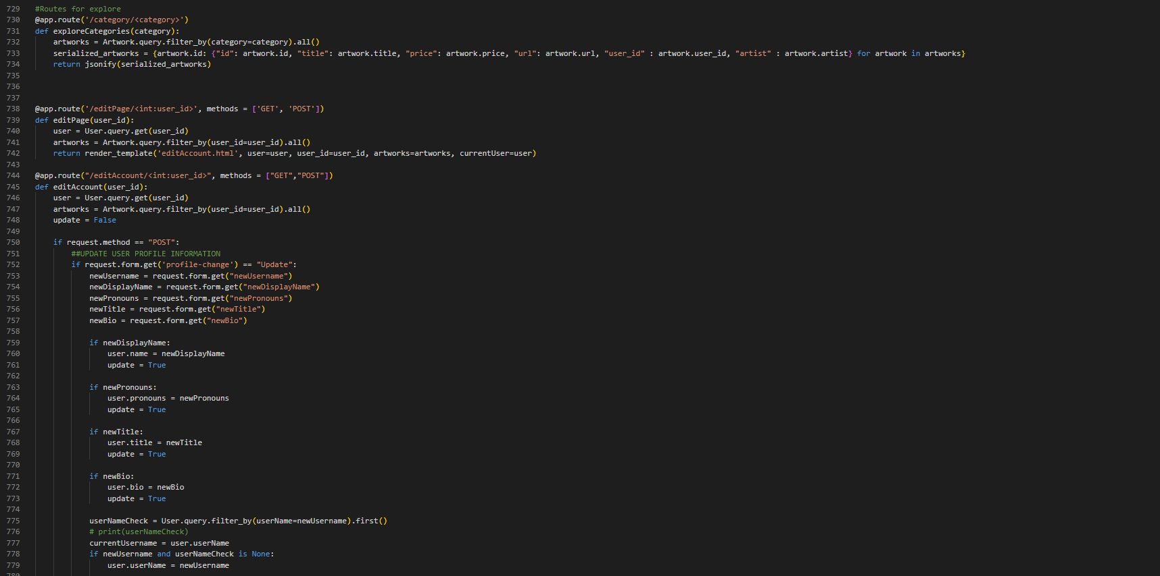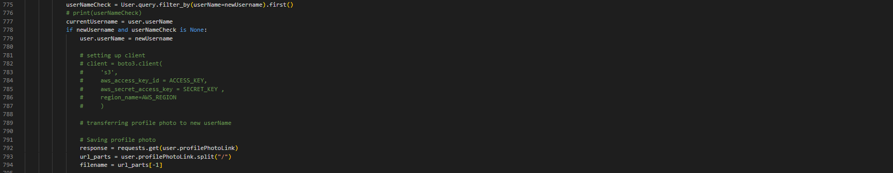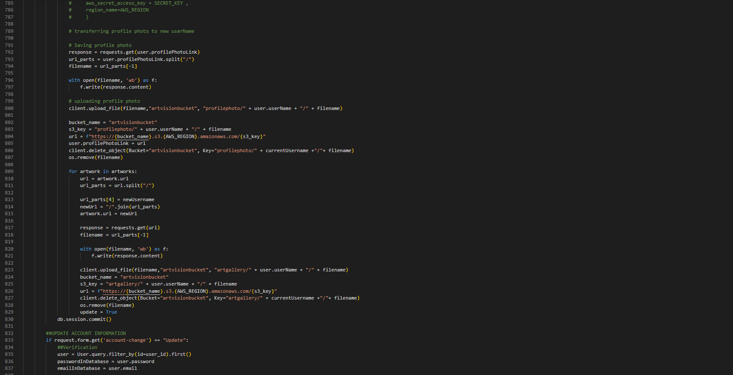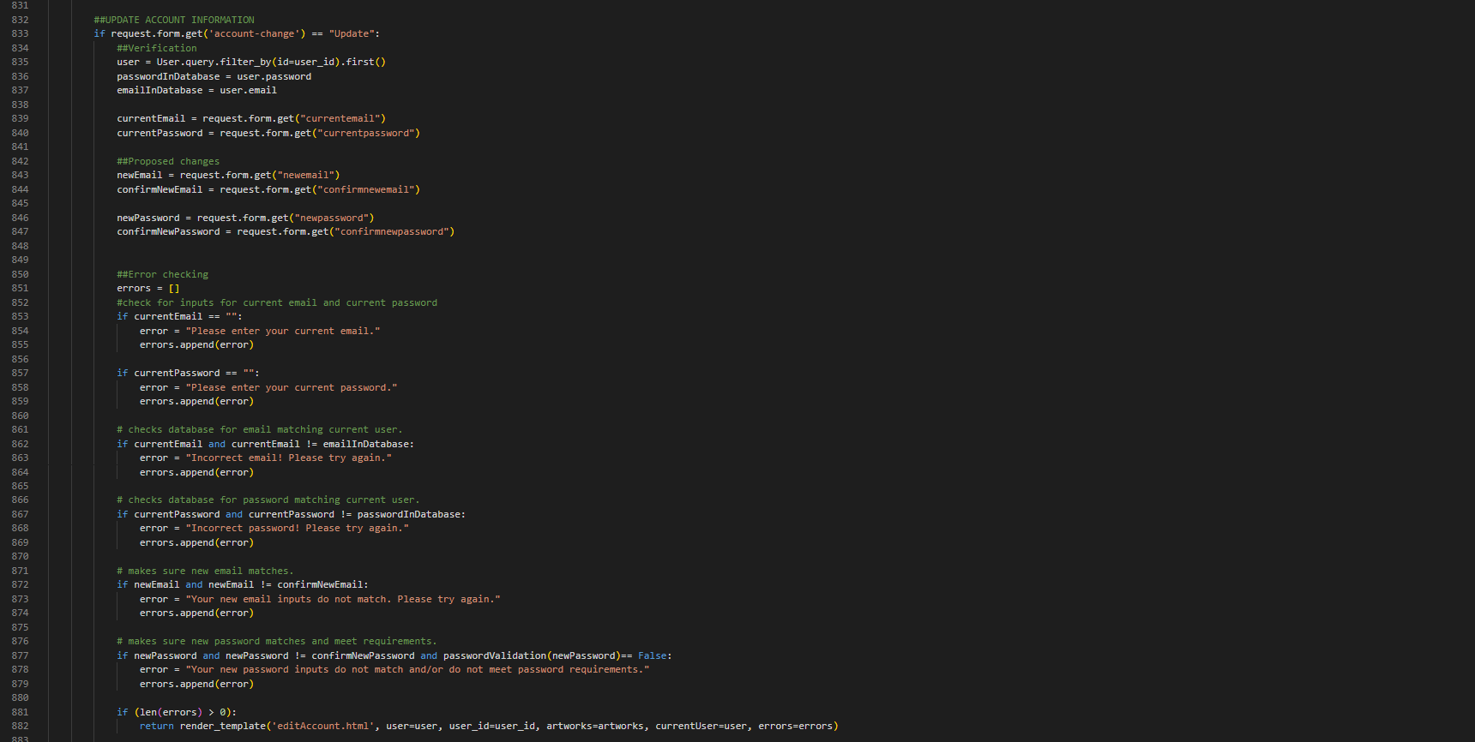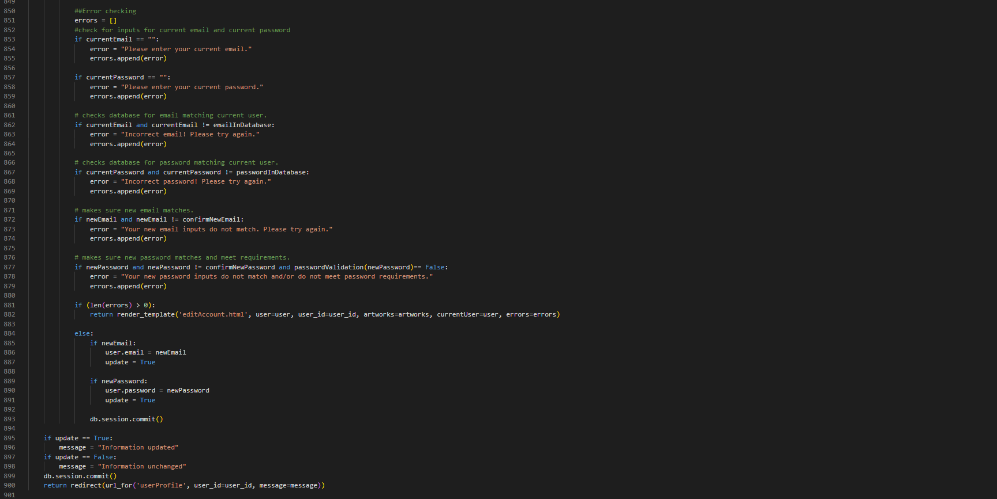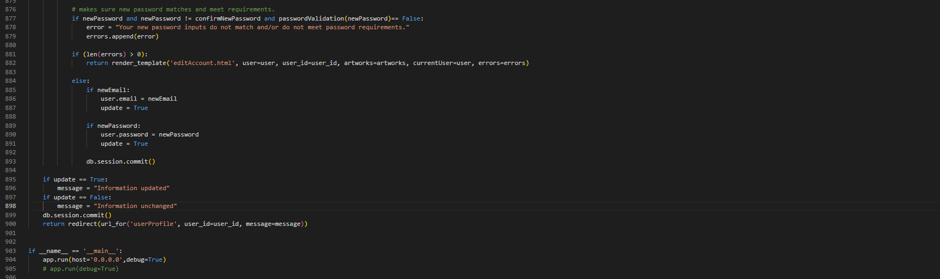

* + **Requirements.txt:**

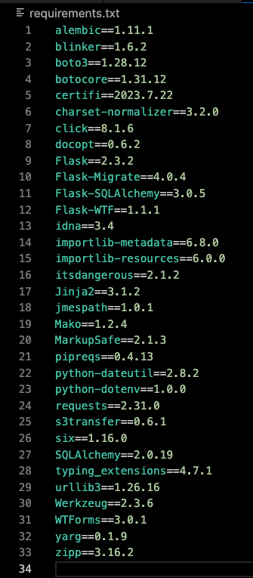

1. **Discussion / Future Expansion**

Although some minor site features were not implemented before our development deadline, we believe that we have achieved all of our major goals for the development of ArtVision. Users can submit their artwork to their galleries and/or shops, manage their accounts, provide feedback on other users’ artwork, purchase prints, and navigate the site’s database of artwork through various means.

Ideas for future expansion of ArtVision include giving users the ability to send friend requests and direct messages, creating a comment section or guestbook feature for users’ profiles, sending users notifications when they receive comments or favorites on their artwork, bolstering security features (e.g. password hashing, email confirmation, etc.), and exploring more opportunities to utilize AWS and enhance both performance and scalability of our website.

1. **Conclusion**

ArtVision’s successful development is a testament to our team's tenacity and highly collaborative efforts that merged a surprisingly diverse array of skill sets. We have built a practical yet beautiful application with features that truly support our goal of creating a space for art enthusiasts to share and further their craft with like-minded individuals. However, with the understanding that there is always room for improvement, we anticipate adding new features such as those discussed in the previous section to support ArtVision’s growth as a vibrant hub of creativity.

1. **References**

* **W3Schools | HTML <input type="file">**
  + This resource was instrumental to understanding how users can upload files on a website, a crucial functionality for a platform where artists submit artworks.
  + Source: <https://www.w3schools.com/tags/att_input_type_file.asp#:~:text=The%20%3Cinput%20type%3D%22file,tag%20for%20best%20accessibility%20practices>
* **Stack Overflow | Flask HTML Loops**
  + The guidance from this resource was beneficial for handling data display in our Flask application.
  + Source: <https://stackoverflow.com/questions/45167508/flask-template-for-loop-iteration-keyvalue>
* **Amazon Web Services | AWS Architecture Center:**
  + This resource was essential in helping us understand and implement cloud-based solutions for our platform, offering numerous well-documented patterns, designs, and best practices.
  + Source: [https://aws.amazon.com/architecture/?cards-all.sort-by=item.additionalFields.sortDate&cards-all.sort-order=desc&awsf.content-type=*all&awsf.methodology=*all&awsf.tech-category=*all&awsf.industries=*all&awsf.business-category=*all](https://aws.amazon.com/architecture/?cards-all.sort-by=item.additionalFields.sortDate&cards-all.sort-order=desc&awsf.content-type=*all&awsf.methodology=*all&awsf.tech-category=*all&awsf.industries=*all&awsf.business-category=*all)
* **Pallets Projects**
  + **Flask-SQLAlchemy documentation**
    - This extensive resource was pivotal in our understanding and utilization of the Flask-SQLAlchemy extension, which greatly simplified interaction between Flask and our database.
    - Source: <https://flask-sqlalchemy.palletsprojects.com/en/3.0.x/>
  + **JavaScript Fetch and JSON**
    - Source: <https://flask.palletsprojects.com/en/2.3.x/patterns/javascript/>
  + **Jinja Documentation**
    - Source: <https://jinja.palletsprojects.com/en/3.1.x/templates/>
* **Miguel Grinberg | Implementing User Comments with SQLAlchemy**
  + We chose to implement the basic comment solution (no reply function) illustrated in this resource.
  + Source: <https://blog.miguelgrinberg.com/post/implementing-user-comments-with-sqlalchemy>
* **Stack Overflow | Multiple submit buttons in form**
  + The answer provided here was used to handle actions for the two update buttons on the Edit Account page.
  + Source: <https://stackoverflow.com/questions/65938462/multiple-submit-buttons-in-flask>
* **Stack Overflow | SQLAlchemy database models to JSON**
  + This resource was used to understand how to serialize our database models for conversion to JSON. This was necessary to display user-submitted artwork and the corresponding details in the landing page, registration page, and login page’s slideshow backgrounds.
  + Source: <https://stackoverflow.com/questions/14920080/how-to-create-sqlalchemy-to-json>
* **SQLite Viewer**
  + We used this to easily view information in our SQL database.
  + Source:<https://inloop.github.io/sqlite-viewer/>
* **Python Docs | datetime** 
  + Source: <https://docs.python.org/3/library/datetime.html>
* **ChatGPT**
  + This resource was primarily used to generate ideas for technologies we could use for development of this project as well as quick debugging tips.
  + Our use of this resource meets the Guidelines for Artificial Intelligence Use at UAB that was shared by President Ray Watts.
  + All of our project’s code was written directly by our team members. Absolutely no portion of our code was copied from ChatGPT output.